**Orthopedic Surgery Gaming App - Project Notebook**

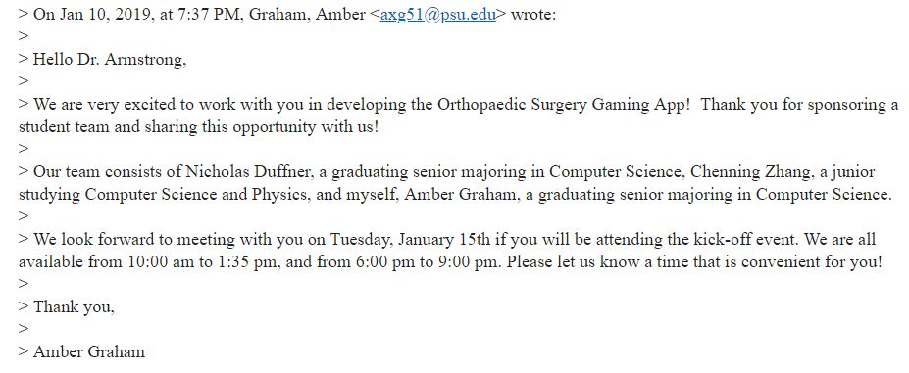

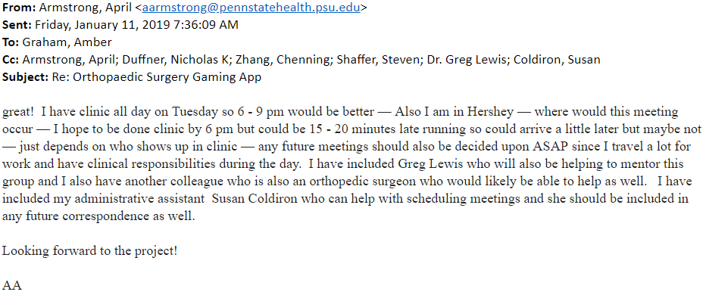

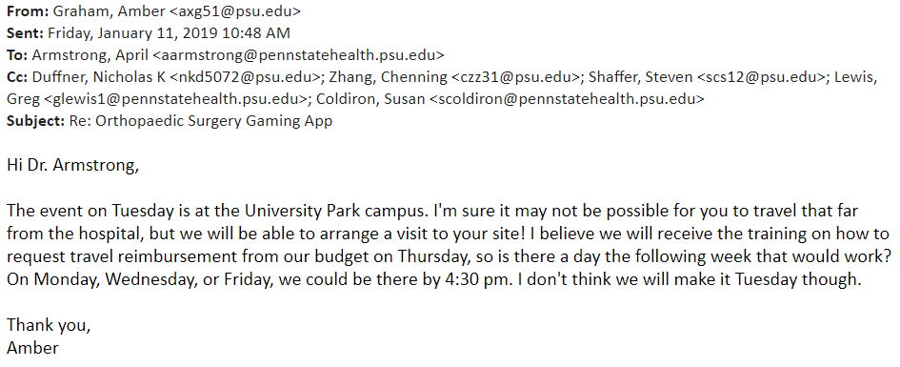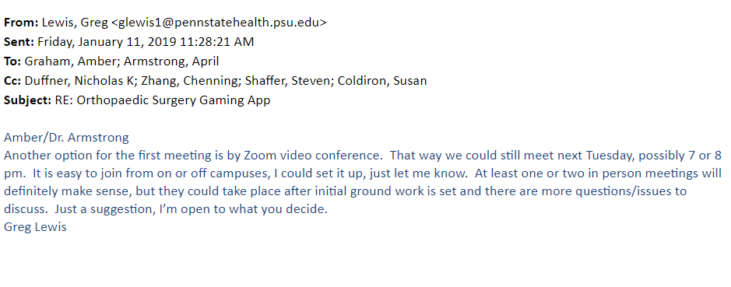

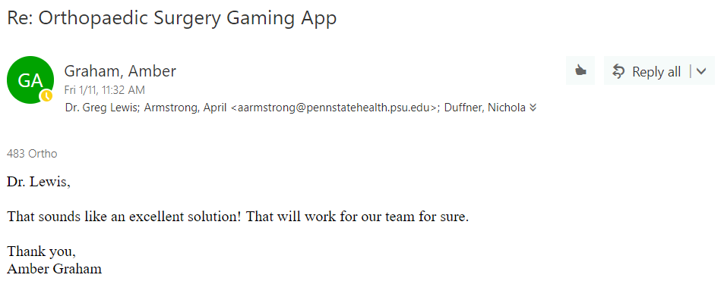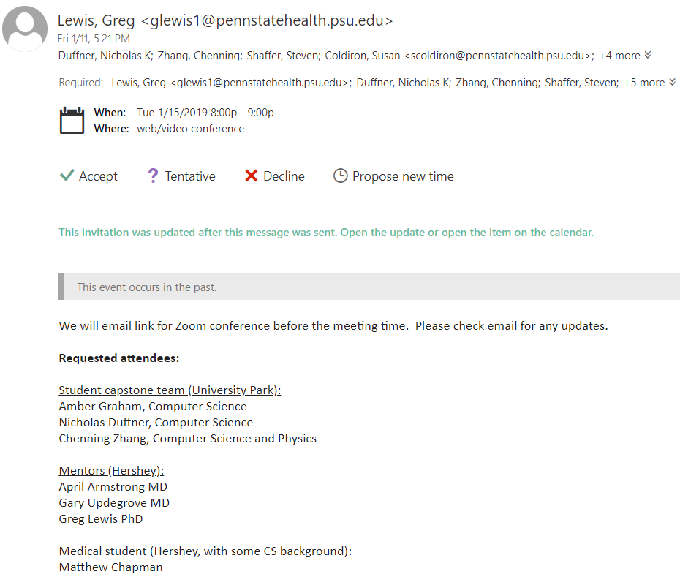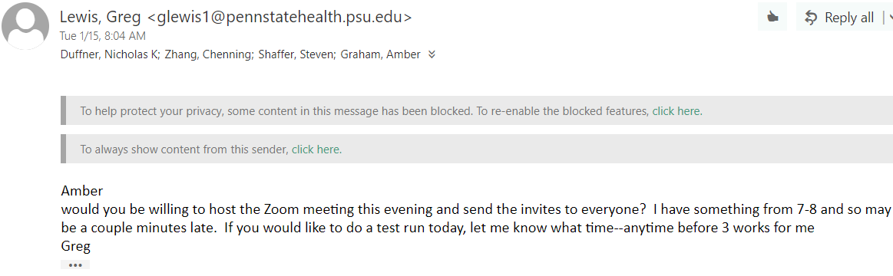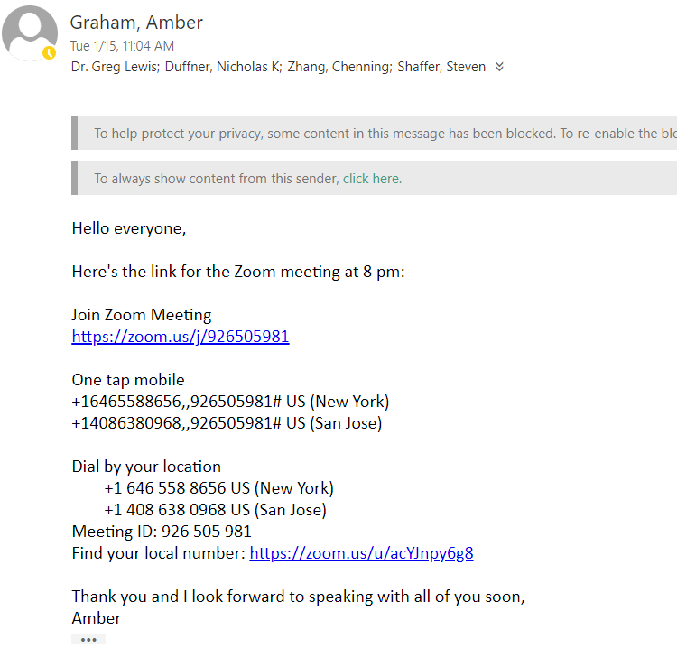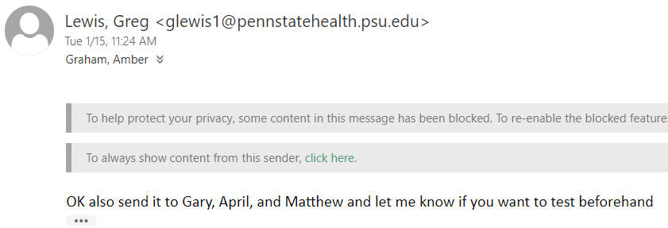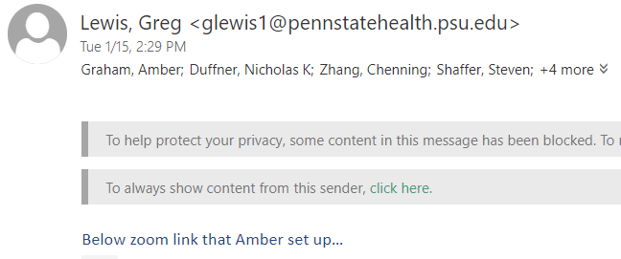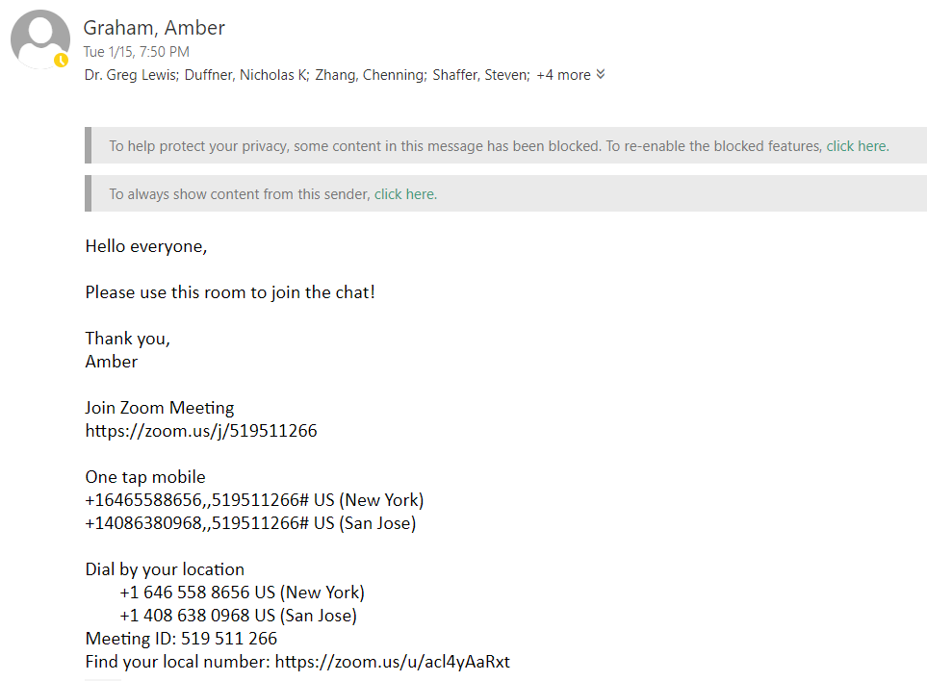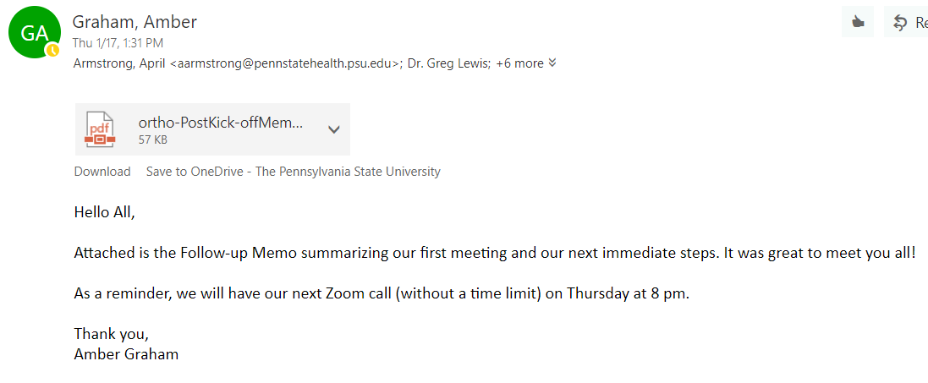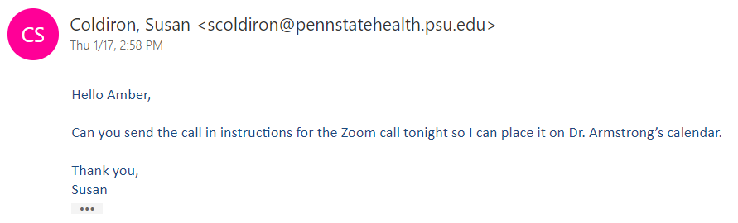

**1/17/2019**

Notes taken from first Zoom meeting with sponsors:

* There is low diversity in orthopaedic surgery
* Most people are not introduced or aware of orthopaedic surgery until it’s too late
  + More males are introduced early because of sports
* Sponsors want something to make orthopaedic surgery fun and informative
  + Intended for high school students
* Game should start with a specific trauma scenario
  + Ex: fracture fixation, ACL tear, torn rotator cuff
* To introduce students to necessary topics, could have an intro on basic human anatomy
* Similar existing app: Touch Surgery (this is too informative and not as engaging)
* Want students to be able to diagnose injuries by symptoms
* Game could include series of mini games for different surgeries
* Make it “cartoonish” so it is more entertaining to young people
  + Want young people to be aware of what Orthopaedic Surgeons really do
* Should be implemented as an iOS/Android app
* *Question:* what are the time expectations for the project and how elaborate can this be?
* Simplicity of the game will be up to the student group
* *Next:* Look at current fun games and see how to integrate Orthopaedic Surgery info

**Orthopaedic Surgery Gaming App - Kick-Off Memo**

**To:** Dr. April Armstrong,

Dr. Gary Updegrove,

Dr. Greg Lewis,

Mr. Matthew Chapman, Penn State Hershey Medical Center

**From:** Amber Graham, Nicholas Duffner, Chenning Zhang

**Subject:** Follow-up for Zoom Call (Project Kick-Off Meeting) on Tuesday 1/15/2019

**Date:** January 17, 2019

**Current Project Status:**

* We held our initial conference call for sponsors and student team to meet.
* We have decided to set our initial goal to creating a mobile gaming app with three surgical procedures for the player to complete.
* The first procedure will guide the user through, with the second having less guidance and the third being more of an evaluation.
* The games will focus on procedure and technique as well as studying the anatomy of the area affected, including muscles, bones, veins, and arteries.
* If we are able to implement this game ahead of schedule, we will work on incorporating a Role Playing Game setting to make the game more engaging and we will include more procedures.

**Team Meetings:**

* Team will meet in class with Professor on Tuesdays at 11:15 am. We will work together during regularly scheduled class time and any other time as needed.

**Work Performed:**

* Sponsors outlined expectations and provided more details for project description.
* Student team began researching tools, such as Unity, to assist in development of gaming app.
* Student team began working out a timeline.

**Future Work:**

* Next Meeting: Zoom Call on Thursday 1/24/2019 at 8 PM
* Student team will meet with Professor to determine best method for game development.
* Student team will research existing apps or games that include the same type of orthopaedic details.
* Sponsor team, please provide 3 surgical procedures/trauma scenarios we can use to begin planning game layout.

**1/22/2019**

*Team Meeting Times:* Tuesdays 11:15 - Scheduled in class. Team meeting following during regularly scheduled class time. On Thursdays during regular schedule as needed.

Communication within team through GroupMe.

*Division of Responsibilities:*

* Note taking: Nicholas
* Budget: Chenning
* Communication with sponsor: Amber
* Software Development: Whole Team

*Tardiness/Absence Policy:* Consistent communication through the GroupMe will be paramount in this project. The expectation will be that each team member will respond to important messages that require team input within 2 hours if the message is sent between 9 AM to 9 PM. If a team member has to miss a meeting with the professor, our sponsors, or just the rest of the team, they will have to give prior notice at least 1 hour before the scheduled meeting. If a team member misses 2 or more meetings without prior notice, the professor will be contacted accordingly.

*Ground Rules:*

* When the team is meeting together, they will only be working on this project.
* Team members will not be on their phones for extended periods while in meetings.

*Decision Making:* We will develop a rotating schedule for team leader on a weekly basis. We will agree as a team based on individual workloads outside of class. Following meeting with professor, we feel that this is a good option.

**Orthopaedic Surgery Gaming App - Week 1 Status Report**

**To:** Dr. April Armstrong,

Dr. Gary Updegrove,

Dr. Greg Lewis,

Mr. Matthew Chapman, PSU Hershey College of Medicine 2

**From:** Amber Graham, Nicholas Duffner, Chenning Zhang

**Subject:**  Progress Update for Week of January 21, 2019

**Date:** January 22, 2019

**Current Project Status:**

* Planning scope of project.
* Awaiting inputs from sponsors for surgical procedures to use for the game.
* Met with class to cover reimbursement procedures and expense reporting.

**Work Performed:**

* Researched current surgery gaming apps.
* Currently researching development software to create game.
* We had weekly meeting with Professor, and weekly meeting with team.
* Established Tardiness/Absence policy as well as ground rules and division of labor for the project going forward. This included how we will be appointing decision maker for the project each week.

**Team Meetings:**

* Team will meet in class with Professor on Tuesdays at 11:15 am. We will work together during regularly scheduled class time and any other time as needed.

**Future Work:**

* Next Meeting: Zoom Call on Thursday 1/24/2019 at 8 PM.
* Begin planning software development.
* Finalizing initial expectations for a baseline of success for the completion of the project with the professor and sponsors and the given timeframe.

**1/24/2019**

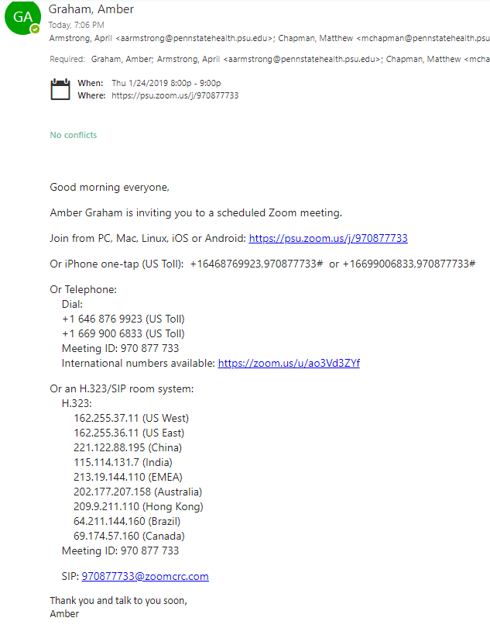

**1/28 - Amber’s notes taken during Zoom call on 1/24**

* Dr. Armstrong visits State College early afternoons on Fridays, so those would be good times to arrange an in-person meeting with her. She can also bring surgical training aids with her to prevent us needing to do a site visit.
* They are expecting an interactive game with 1 or 2 scenarios to start out with a win/lose outcome.
* Something that can be built upon in the future.
* Possibly with a time constraint for performing the procedure.
* We need to figure out licensing problems for using images. The sponsors are looking into providing us with x-ray images we can use that will not include patient information.
* 2-D game incorporating some form of anatomy quiz
* For surgical procedure, we can include a dropdown type list with pictures (maybe a scrollable list) of plates, screws, etc. to choose from.
  + Students have to pick the right procedure
* We can have a patient with multiple injuries.
* Focus on bones, plates, and screws. Not making incisions or casts.
* Objectives of game:
  + ID the anatomy
  + Fix the fractures by choosing what to fix and how
  + See real x-ray images of normal and broken bones
  + Player checks the xray to see if a bone is broken
  + Keep score of right or wrong moves/decisions

- 8 different locations on the body

- Leave out complications for now

- Deliverables: business plan for implementation

- Publishing costs, legal information, practicality

- Send out a poll to schedule next meeting. Wednesdays and Fridays are good. Second or third week of February.

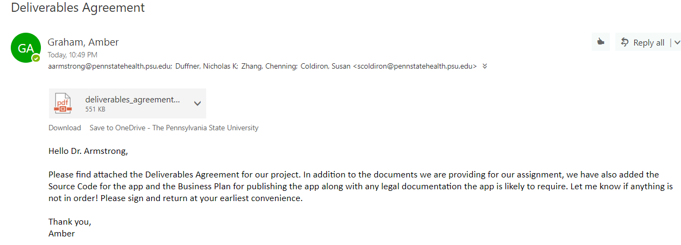

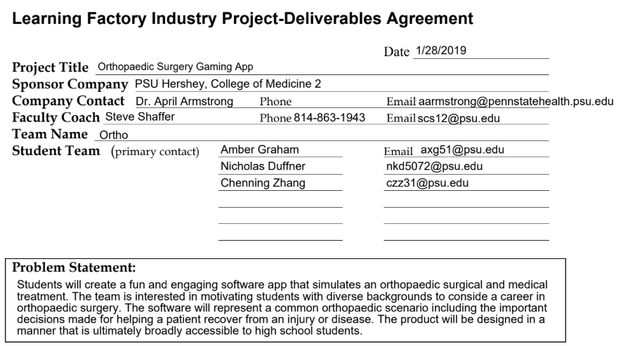

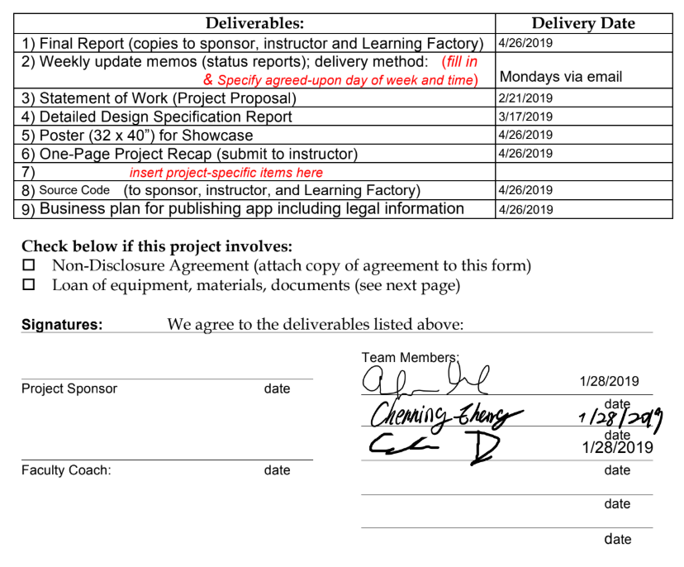

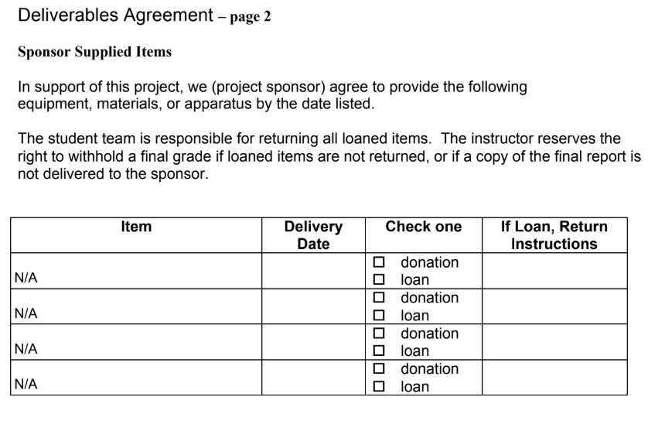

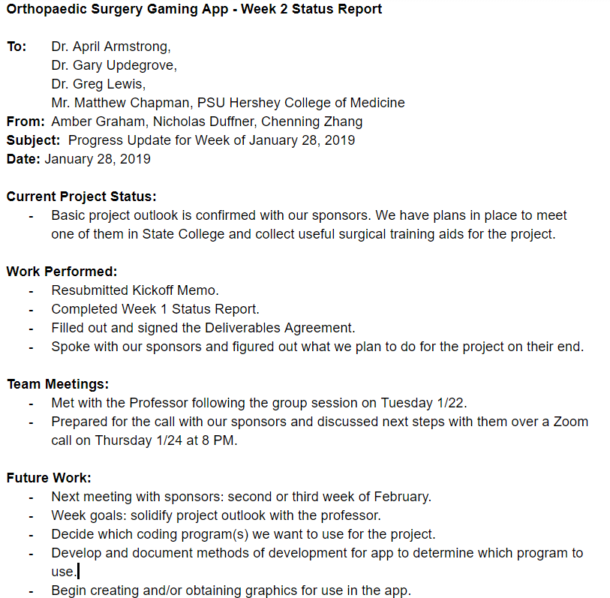

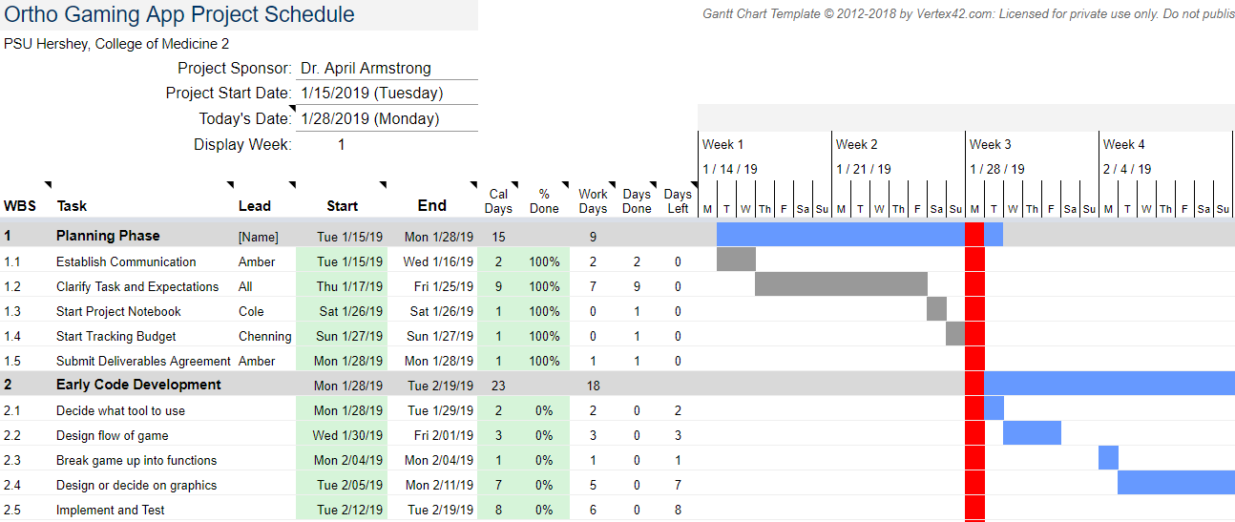

**1/28**

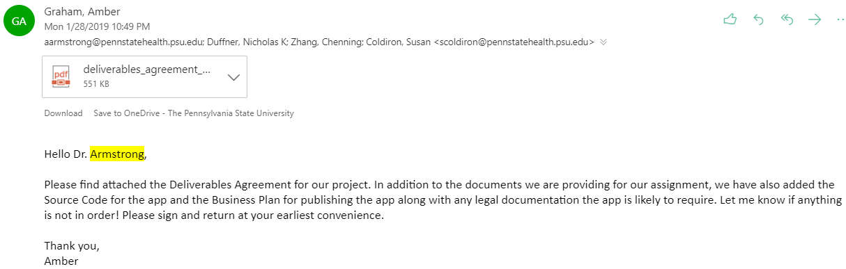

**1/29 - Meeting with Professor**

Chenning - late (11:26)

Check with LF, we can get an art student to draw the figures for us and have it listed on our budget as Work for Hire. We can use some of our budget for this.

Sketch out the procedure and let them edit it.

John Hannon - teaches Apple App development. Good to ask for questions.

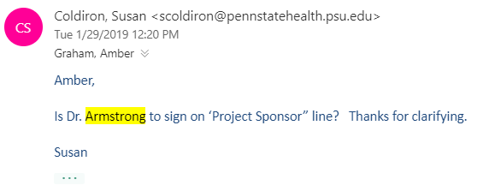

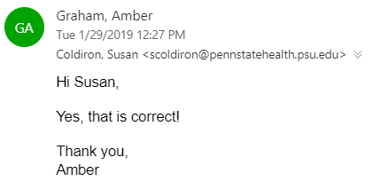

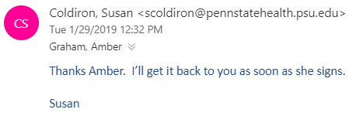

**1/30**

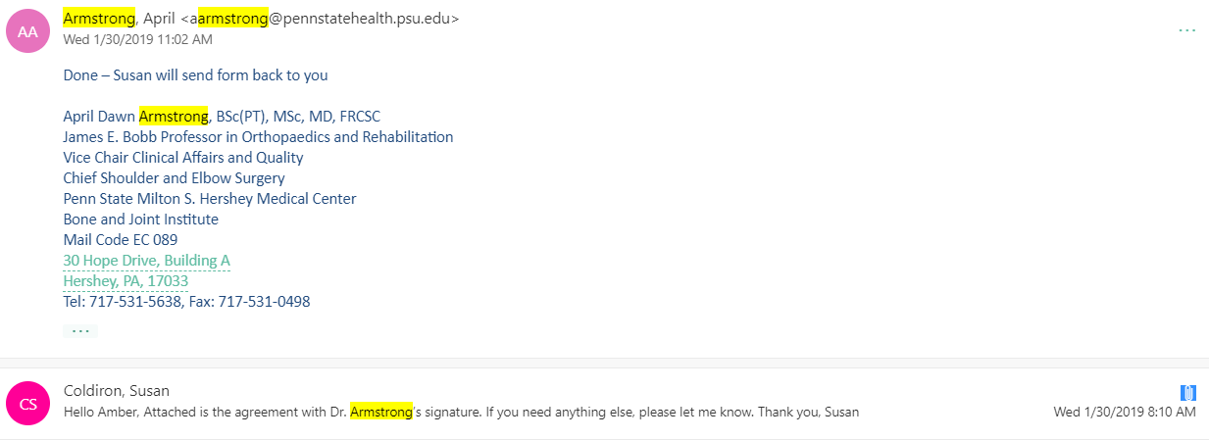

**2/4**

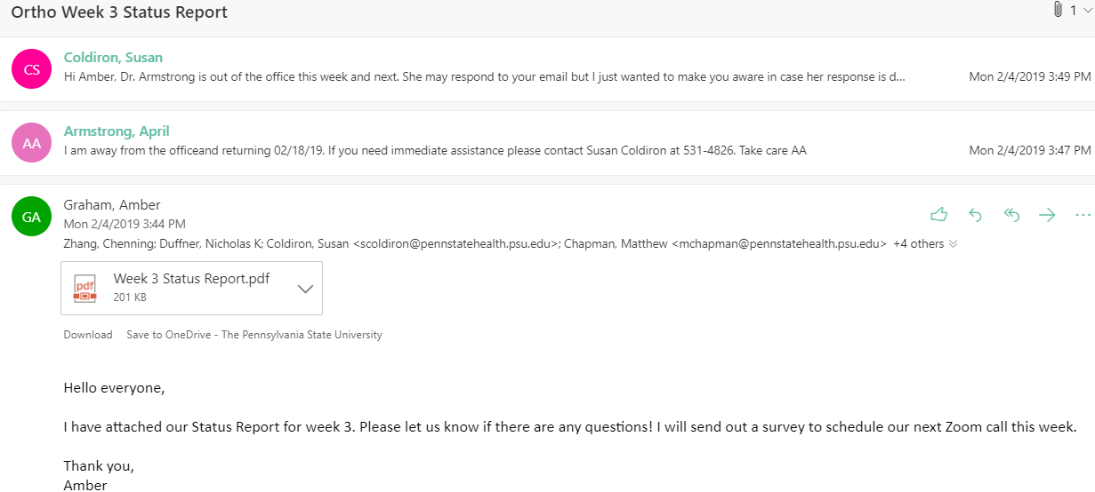

**Orthopaedic Surgery Gaming App - Week 3 Status Report**

**To:** Dr. April Armstrong,

Dr. Gary Updegrove,

Dr. Greg Lewis,

Mr. Matthew Chapman, PSU Hershey College of Medicine

**From:** Amber Graham, Nicholas Duffner, Chenning Zhang

**Subject:**  Progress Update for Week of February 4, 2019

**Date:** February 4, 2019

**Current Project Status:**

* We have selected coding language (C#) and programming software (Unity) for our project and will spend a few days this week becoming familiar with it.
* On Thursday, we will decide the layout of the game and begin developing.

**Work Performed:**

* Submitted On-site Meeting Memo.
* Sent Deliverables Agreement to sponsor and received signed copy.
* Selected software development package for gaming app.
* Created GitHub repository for sharing project code.

**Team Meetings:**

* Met Monday 2/4 to select software and discuss work for the week.
* Will meet with professor Thursday 2/7.
* Will schedule sponsor Zoom call for a date during the next two weeks, pending responses from all for best date.

**Future Work:**

* Week goals: Become familiar with Unity software and C# programming language.
* Next meeting with sponsors: third week of February.
* Decide layout of game and begin to develop. We will divide up work and utilize GitHub for collaboration.
* Begin to create and/or obtain graphics for use in the app.
* Reach out to Dr. Armstrong to figure out when she plans on coming to State College.

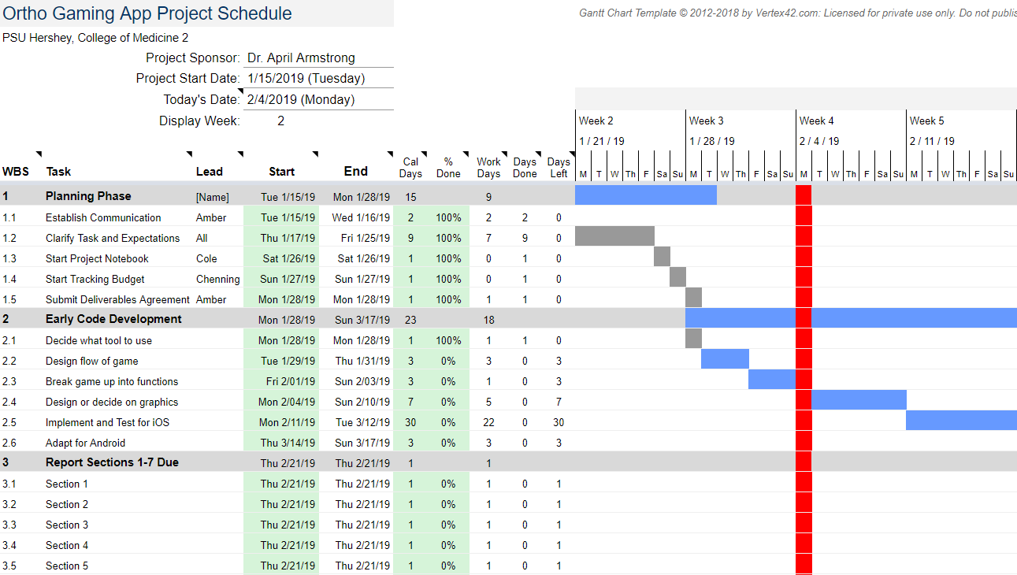

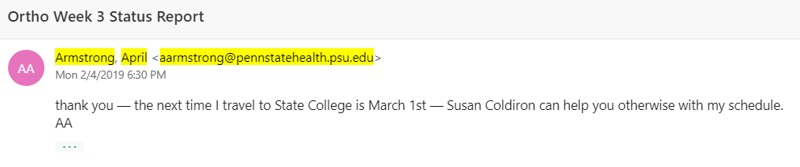

**Meeting With Professor 2/7**

* All present and on time
* Good to go with developing skeleton of game to run in Unity
* Different Conditions - multiple choice
* Storyboard and get approval from client
* Split up - storyboard and get Unity running
* Those two are next week’s goals
* Basic sketches or stock photos for storyboard
* Do storyboard in powerpoint
* Ask Cindy in LF for how to pay someone for artwork
* Have storyboard and unity up by Tuesday, go over with professor
* Dr. Armstrong visit March 1
* Start with something that’s working and then modify from there

**2/11 - Team Work Session**

* All present and on time
* Questions to ask:
  + Ask sponsor about 8 zones of the body/areas so that we know which 8 injuries we are implementing
  + What we are able to do with the LF in order to compensate an artist to make our graphics.
  + What specific procedures the sponsors want us to do
  + How extensive the Anatomy Quiz will be (what is appropriate level expected for high school students to know?)
  + Ask sponsors to draft up a step-by-step for how the surgical procedure will go
* Worked on Storyboard
* Completed Week 4 status report

**Orthopaedic Surgery Gaming App - Week 4 Status Report**

**To:** Dr. April Armstrong,

Dr. Gary Updegrove,

Dr. Greg Lewis,

Mr. Matthew Chapman, PSU Hershey College of Medicine

**From:** Amber Graham, Nicholas Duffner, Chenning Zhang

**Subject:**  Progress Update for Week of February 11, 2019

**Date:** February 11, 2019

**Current Project Status:**

* Layout of game has been drafted. We will get approval from our professor at tomorrow’s meeting, and then present to our sponsors during next Zoom call. Upon review by sponsors, we will enter development phase following Spring Break (3/11).

**Work Performed:**

* Submitted Deliverables Agreement signed by team, sponsor, and professor.
* Created project Storyboard to present to the professor and our sponsors.
* Developed a basic program in Unity.

**Team Meetings:**

* Team met on Monday 2/11.
* Will meet with professor Tuesday 2/12 during class.
* Will schedule sponsor Zoom call for a date during the next two weeks, pending responses from all for best date.

**Goals for this Week:**

* Schedule next Zoom call with sponsors by the end of the week.
* Finalize Storyboard with the professor before presenting to our sponsors.
* Decide how we will obtain graphics for use in the app.
* All team members work through a Unity tutorial by Friday.

**Future Work:**

* Next meeting with sponsors: third week of February.
* Obtain graphics for use in the app.
* Complete Statement of Work Report.
* Present SOW in class.
* Complete Literature/Patent/Prior Work Search and Social Impact.
* Divide game into tasks for each team member.

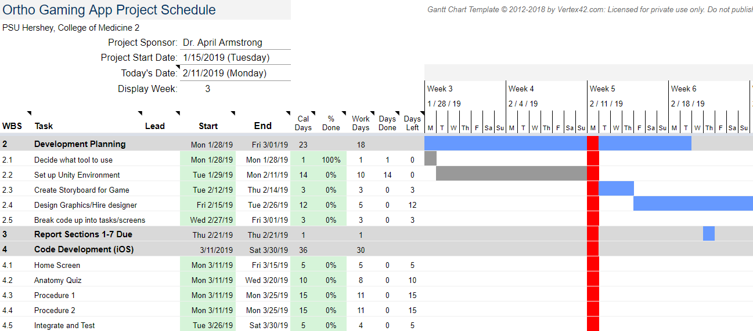

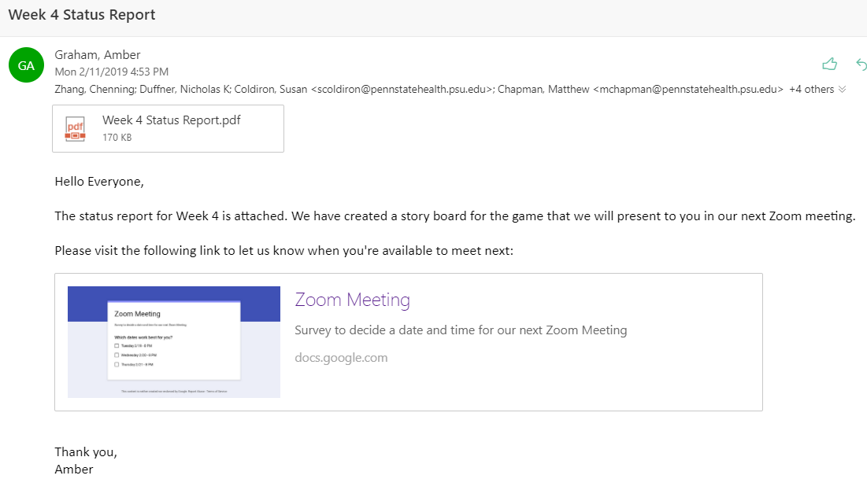

**2/18/2019 - Zoom Survey Responses and Email Replies  
- current best date is Tuesday 2/19**

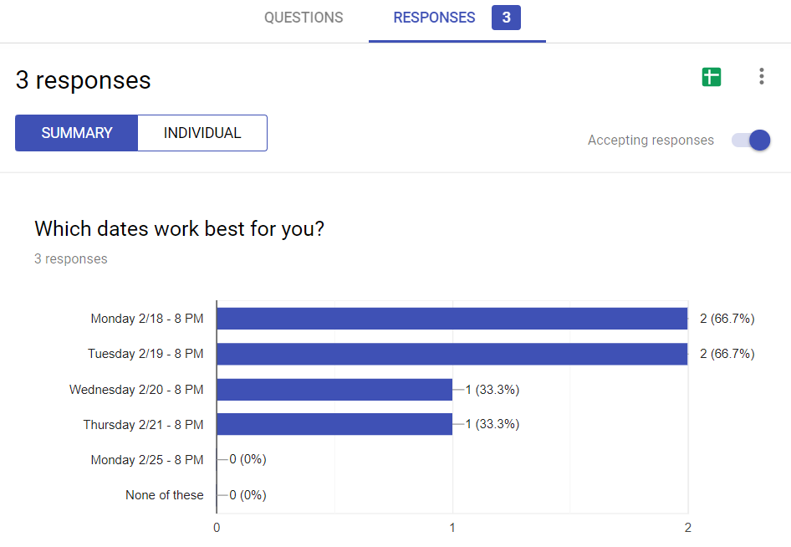

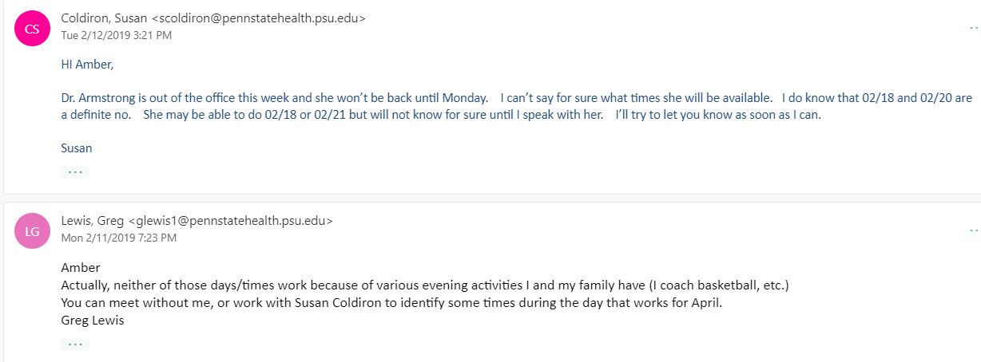

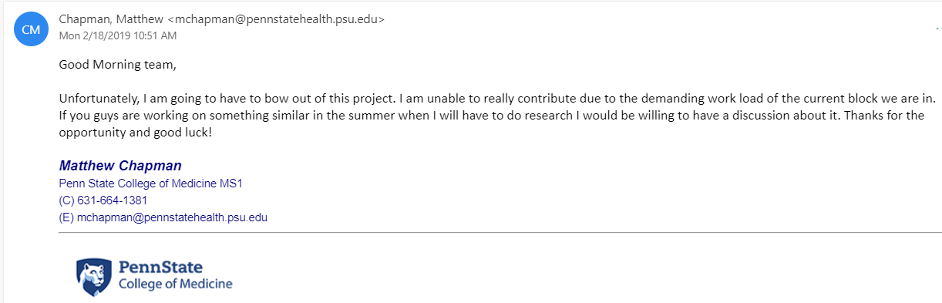

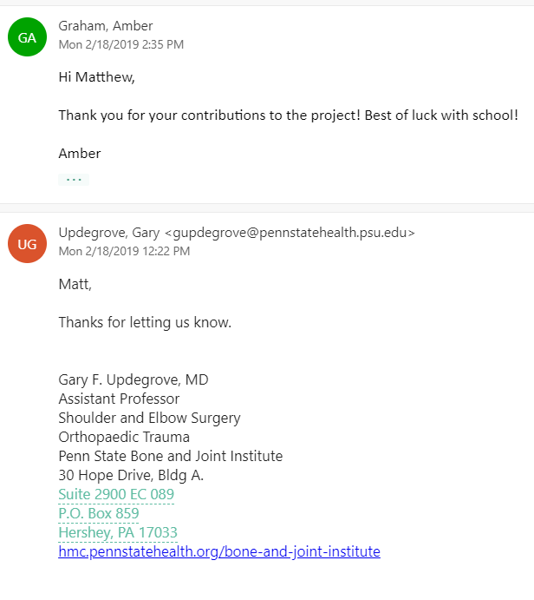

**2/18/2019 - Team Meeting - 4:15 pm**

Everyone present and on time.

**Questions:**

* Can we use some of our budget to purchase existing apps that deal with orthopedic surgery (Bonedoc, app store, $1.99)

**Orthopaedic Surgery Gaming App - Week 4 Status Report**

**To:** Dr. April Armstrong,

Dr. Gary Updegrove,

Dr. Greg Lewis, PSU Hershey College of Medicine

**From:** Amber Graham, Nicholas Duffner, Chenning Zhang

**Subject:**  Progress Update for Week of February 18, 2019

**Date:** February 18, 2019

**Current Project Status:**

* Layout of game has been drafted. We will seek to meet with our professor to present it to him during office hours (due to snow cancellation for last week’s meeting), and then present to our sponsors during next Zoom call. Upon review by sponsors, we will enter development phase following Spring Break (3/11).

**Work Performed:**

* Created Statement of Work (SOW) presentation to outline report and present to class.
* Snow delay caused postponement of presenting Storyboard to professor.
* Developed a basic program in Unity.
* All team members worked through a Unity tutorial to ensure all are able to use the software.

**Team Meetings:**

* Team met on Monday 2/18 to work on SOW.
* Will meet with professor during office hours if a meeting during class is not possible.
* Polled sponsor team for best date for Zoom call. Still awaiting some responses but prospective date is Tuesday 2/19 at 8 PM.

**Goals for this Week:**

* Present Storyboard to professor and sponsors.
* Finalize Storyboard with the professor before presenting to our sponsors.
* Decide how we will obtain graphics for use in the app.

**Future Work:**

* Obtain graphics for use in the app.
* Complete Statement of Work Report.
* Present SOW in class.
* Divide coding tasks between team members to start following Spring Break.

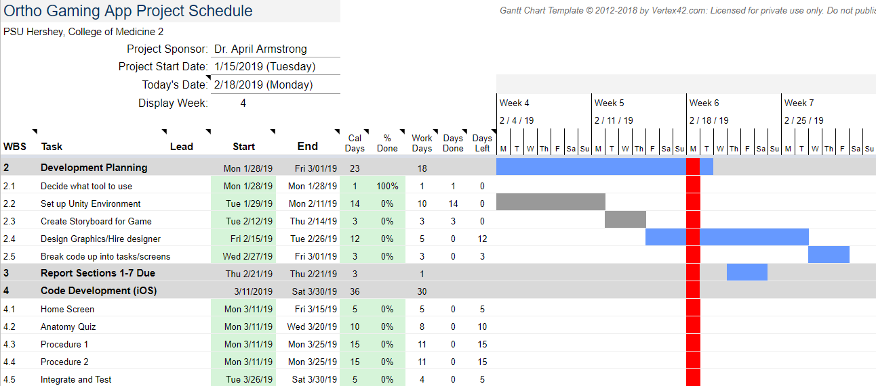

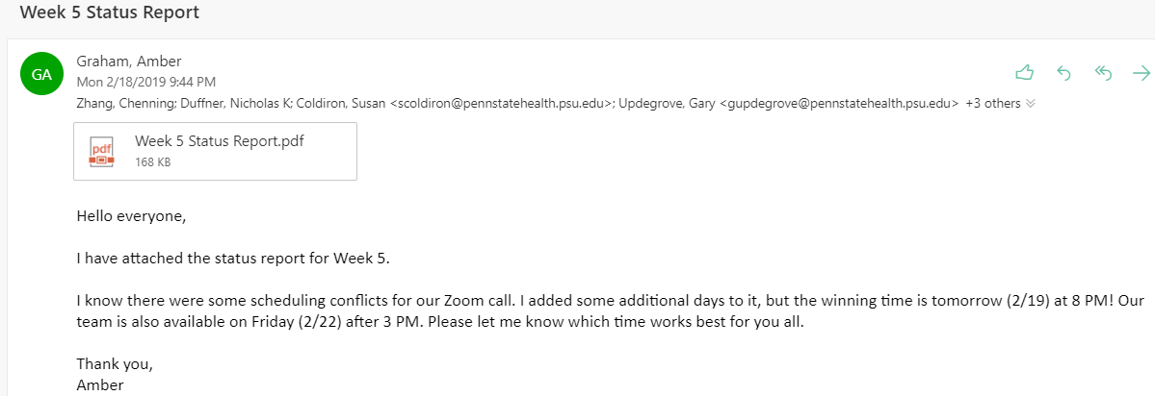

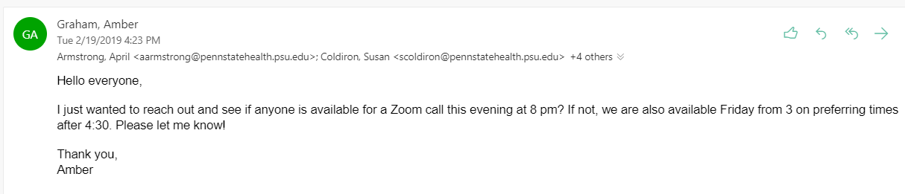

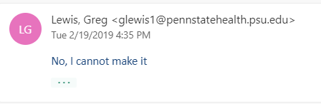

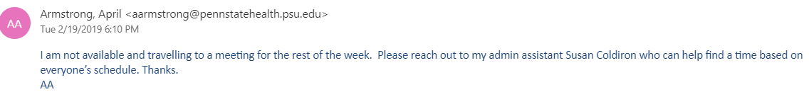

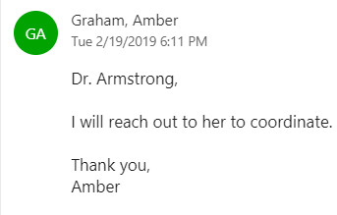

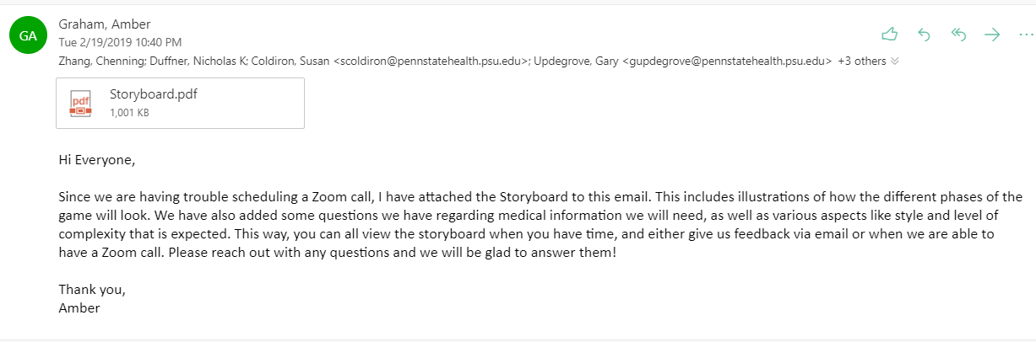

**Storyboard with updated graphics 2/19**

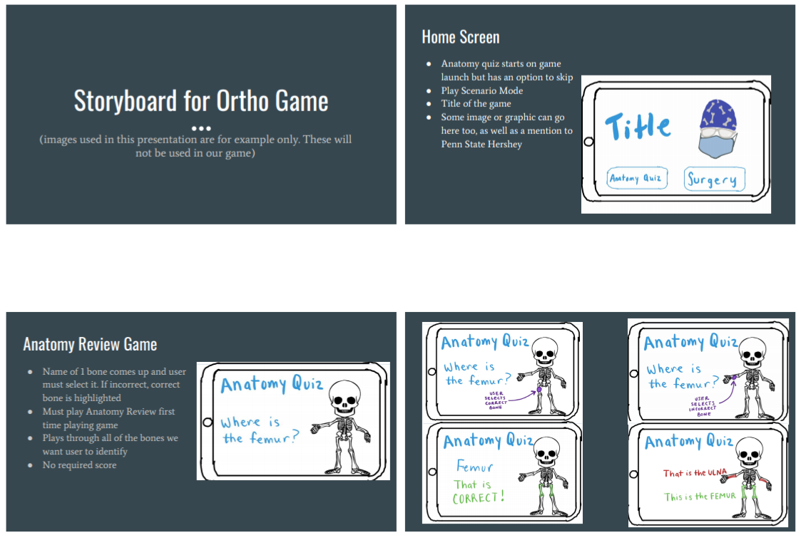

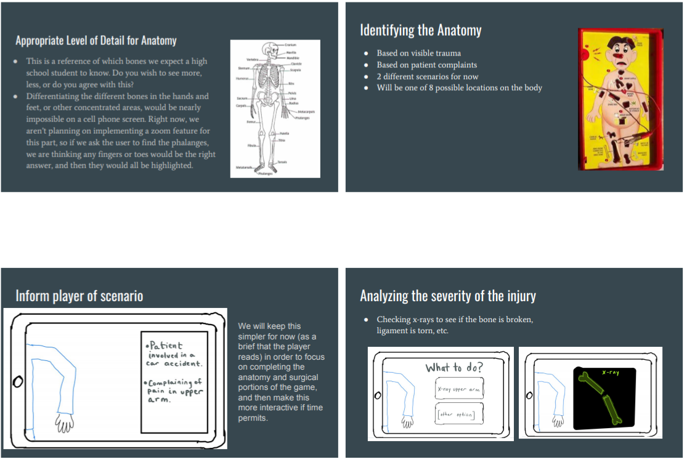

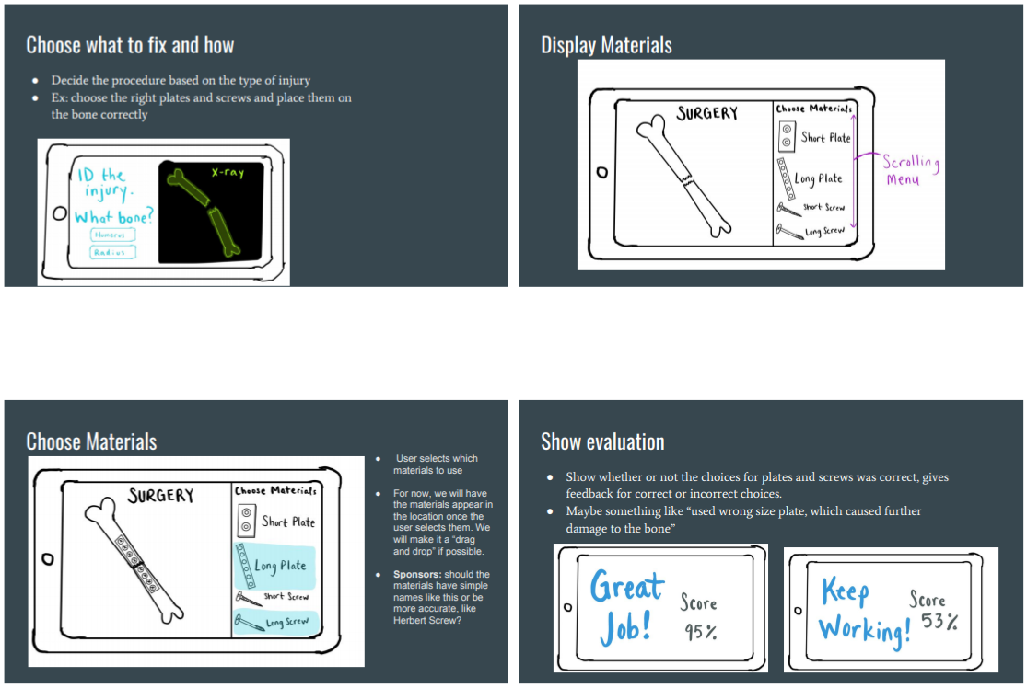

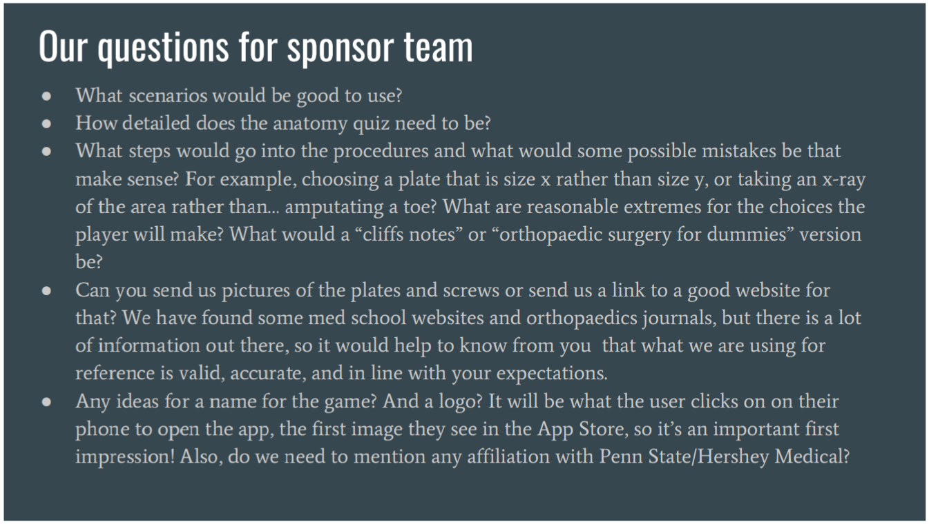

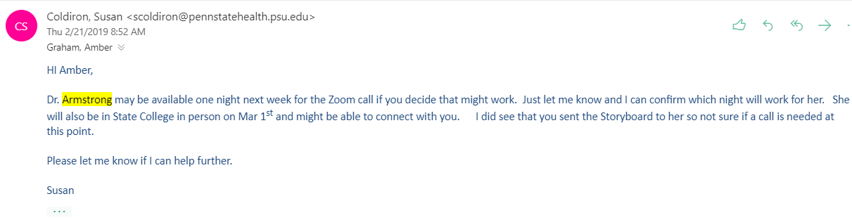

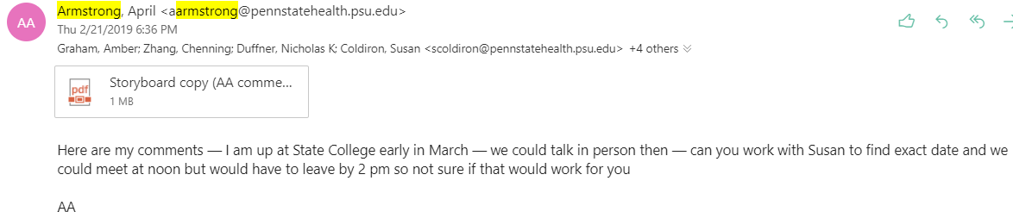

**Slides containing Dr. Armstrong’s feedback on Storyboard (her comments are in red):**

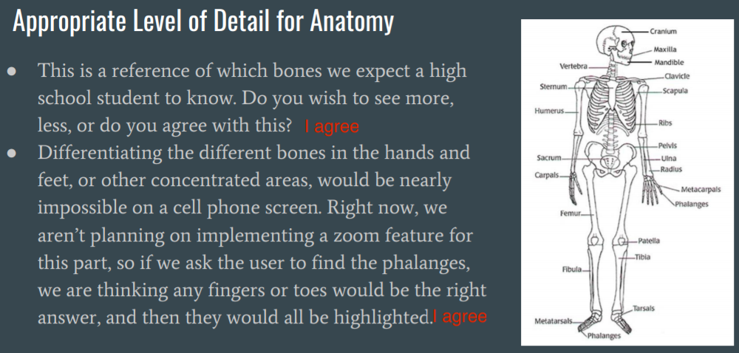

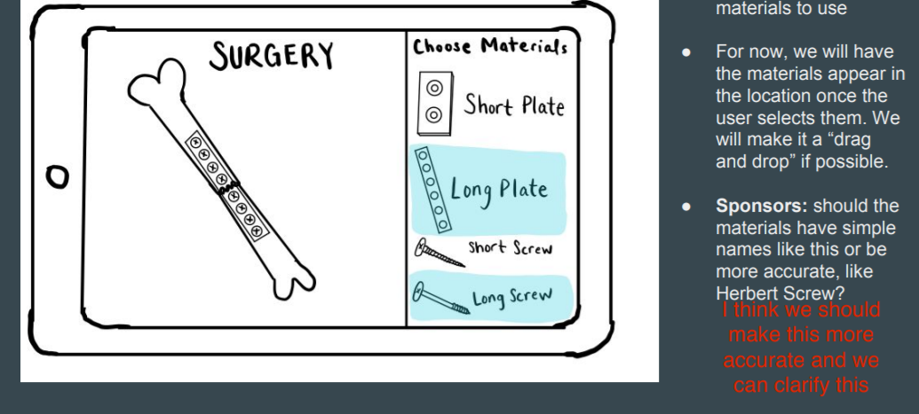

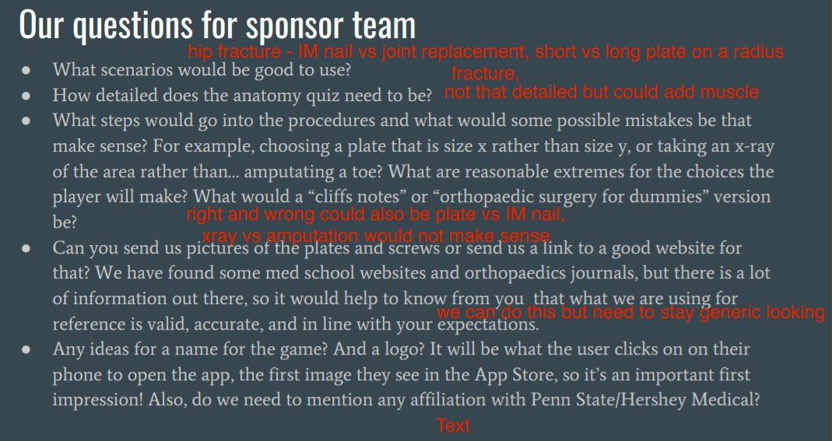

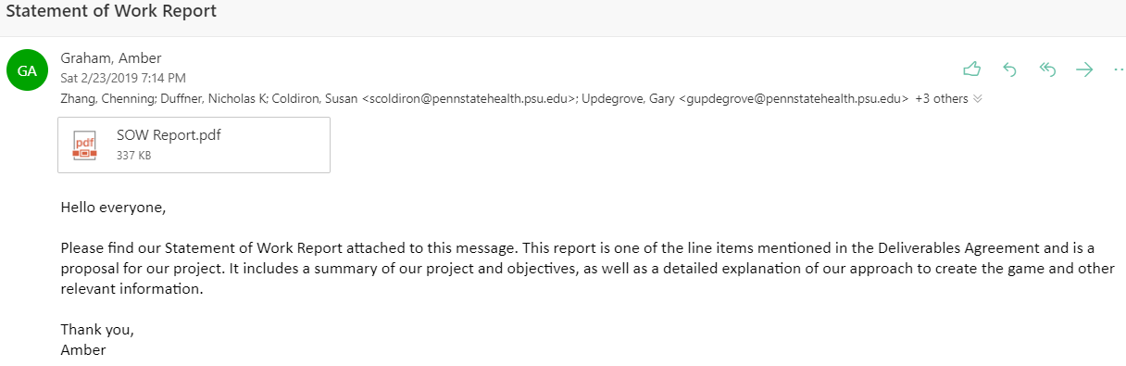

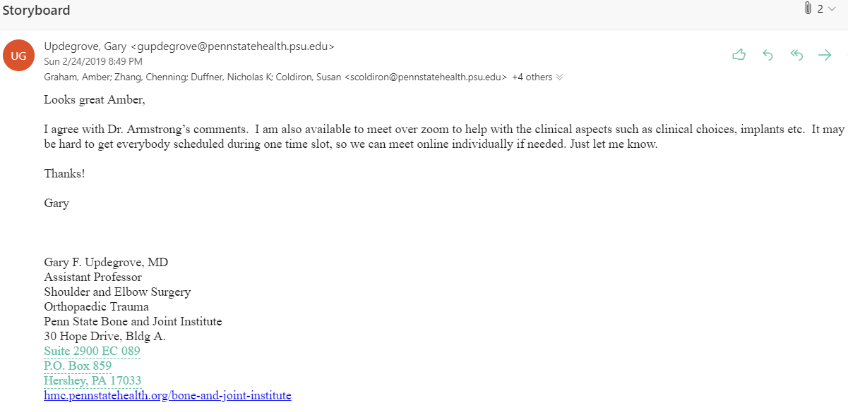

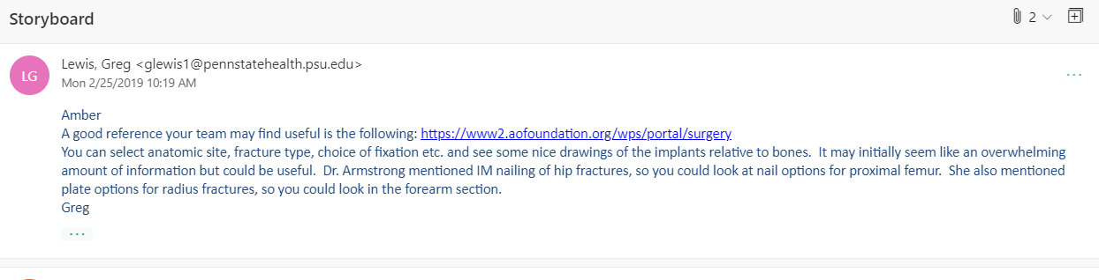

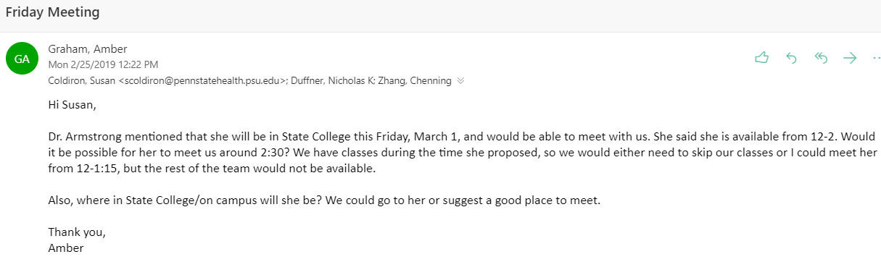

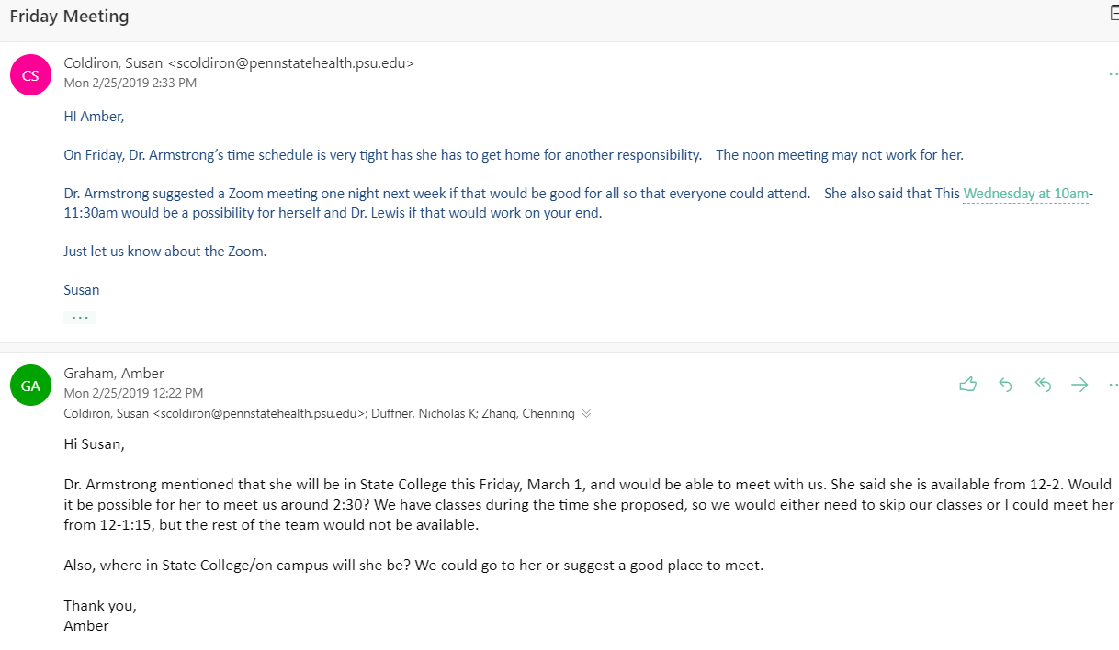

**Orthopaedic Surgery Gaming App - Week 4 Status Report**

**To:** Dr. April Armstrong,

Dr. Gary Updegrove,

Dr. Greg Lewis, PSU Hershey College of Medicine

**From:** Amber Graham, Nicholas Duffner, Chenning Zhang

**Subject:**  Progress Update for Week of February 25, 2019

**Date:** February 25, 2019

**Current Project Status:**

* Awaiting responses from potential graphic designers.
* We have divided up coding tasks among team members to begin development phase following Spring Break.

**Work Performed:**

* Presented Statement of Work (SOW) outline to class.
* Wrote SOW and submitted to sponsors and professor.
* Presented Storyboard to sponsors and received feedback.
* Generated graphics for use in development.

**Team Meetings:**

* Team met on Monday 2/25 to discuss meeting times with sponsors, work on Patent Search assignment, and delegate coding assignments.
* Will meet with professor on Tuesday 2/26.
* Potential Zoom call with sponsors on Wednesday 2/27 pending Dr. Armstrong’s availability.

**Goals for this Week:**

* Perform Patent/Literature/Prior Work Search.
* Create specific stories for Trauma Scenarios based on feedback from sponsors utilizing resources provided by Dr. Lewis.

**Future Work:**

* Obtain graphics for use in the app.
* Set up Unity environment for our game and build our repository on GitHub.
* Start to develop code for the app following Spring Break. Nicholas: Home Screen and Anatomy Review; Amber: Trauma Scenario #1; Chenning: Trauma Scenario #2.

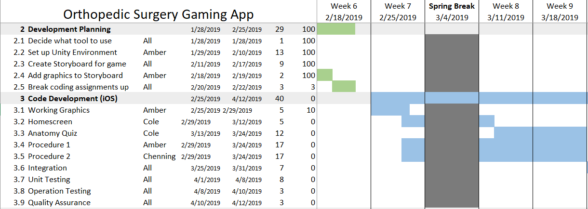

**2/25 - Team Meeting 3 pm**

All team members were present and on time

* Discussed availability for Zoom call with sponsors
* Delegated coding sections to each team member as stated in Status Report
* Found prior work/literature for patent search and divided tasks among ourselves

Completed status report. We are on schedule

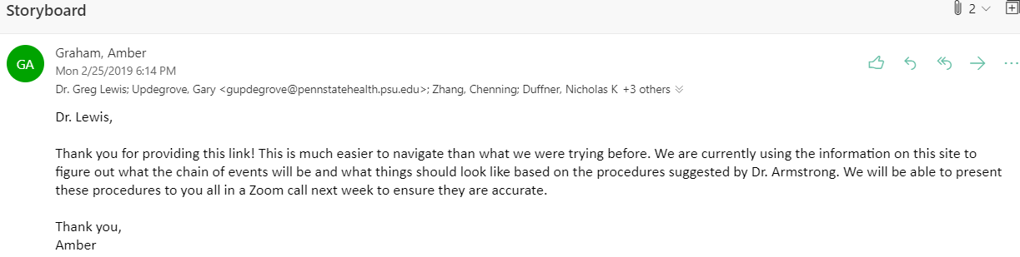

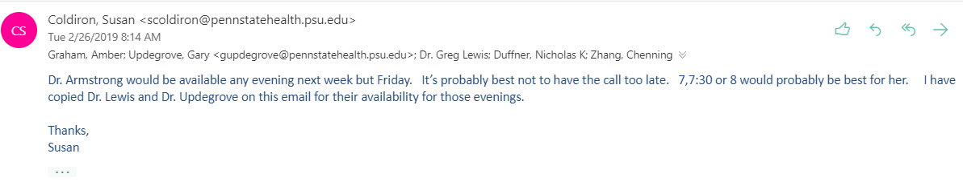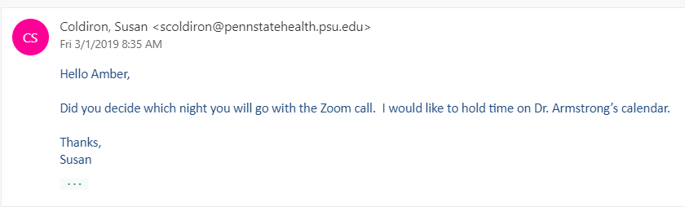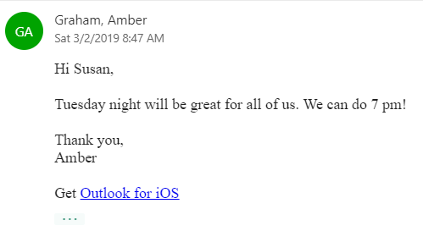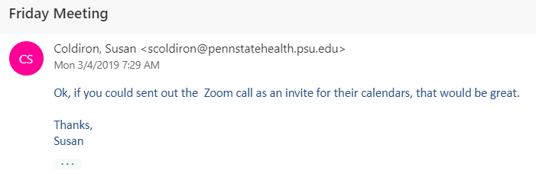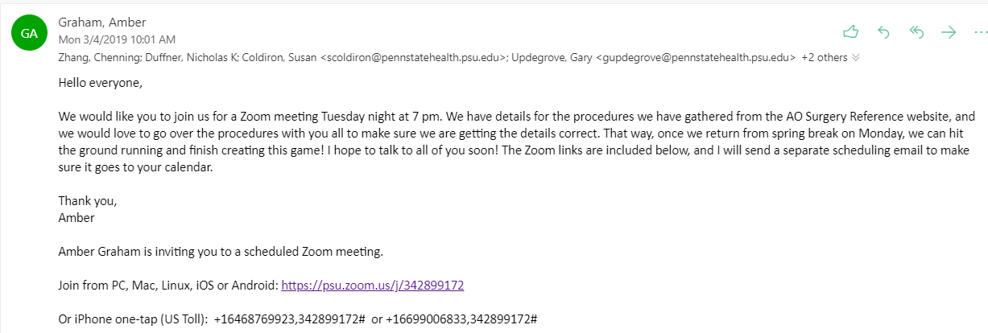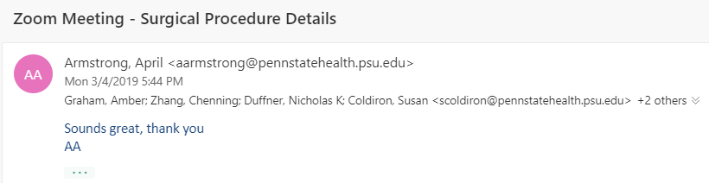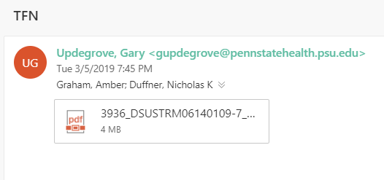

**Zoom Call Tuesday 3/5/2019 7 PM**

**Our team:** Amber and Cole present. Chenning absent.

**Sponsor team:** Dr. Armstrong, Dr. Updegrove, and Dr. Lewis present

Dr. Updegrove shared the file in the above email with us, as well as these links:

https://www.depuysynthes.com/hcp/trauma/products/qs/tfna_proximal…

https://www.orthobullets.com/

https://www.orthobullets.com/trauma/12211/intertrochanteric-fracture-orif-with-cephalomedullary-nail?expandLeftMenu=true

https://www.youtube.com/watch?v=-GLmXGUSCpA

<https://www.youtube.com/watch?v=UZVR3P7b_Ck>

**Purpose of call:** Presented doctors with information Amber collected on the surgical procedures from the website provided by Dr. Lewis to get their feedback and ensure we were using the appropriate procedures.

**Information we presented to them is in the next few pages, followed by the feedback we received from them.** Overall, they were very satisfied with the information gathered. They had a few clarifications and details we could omit or make more streamlined.

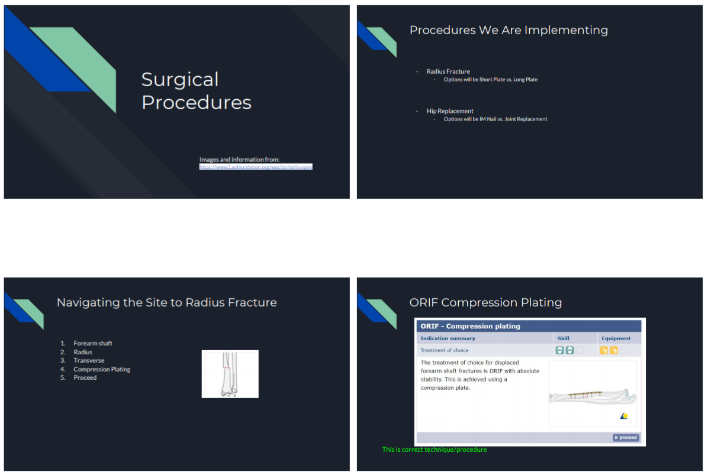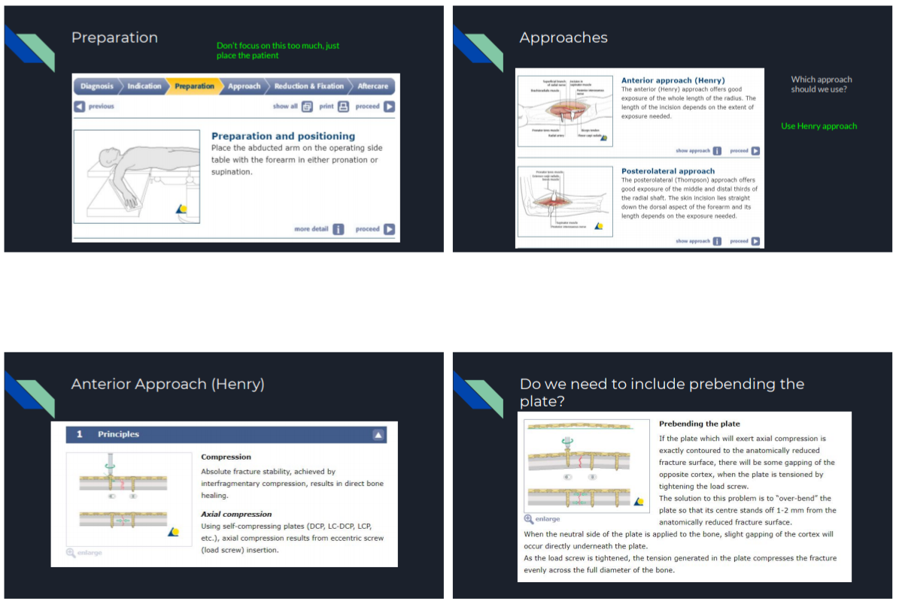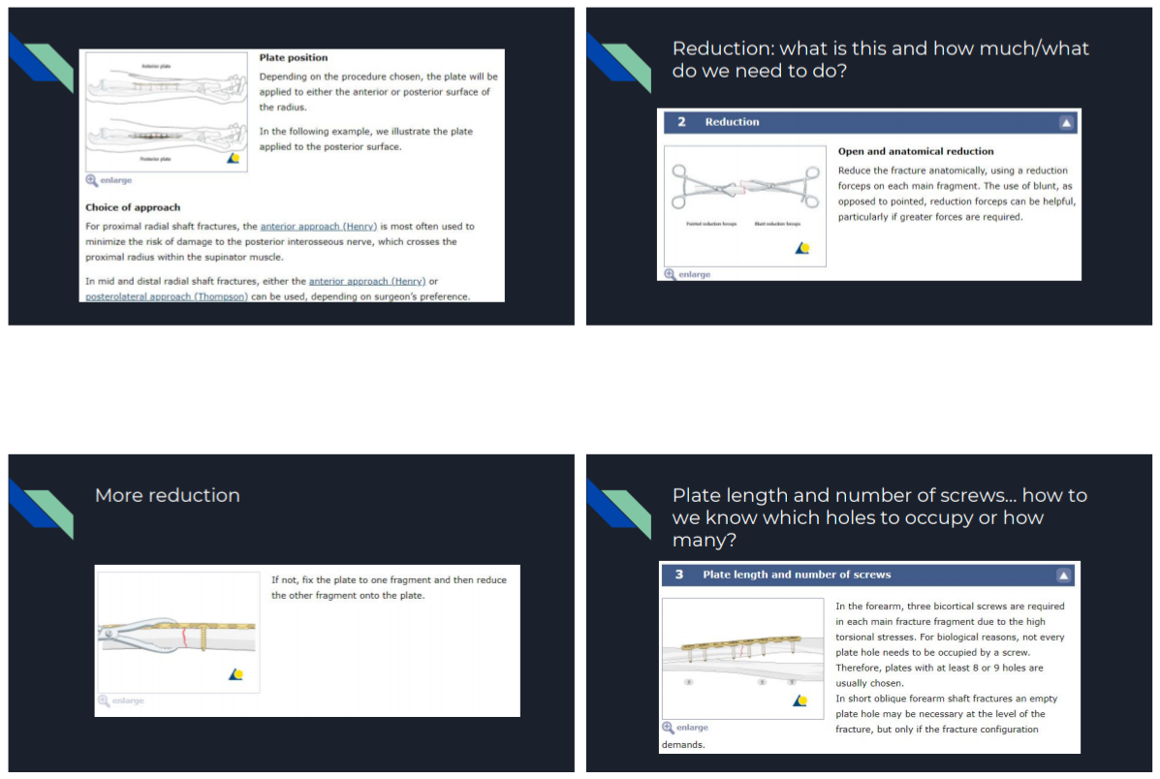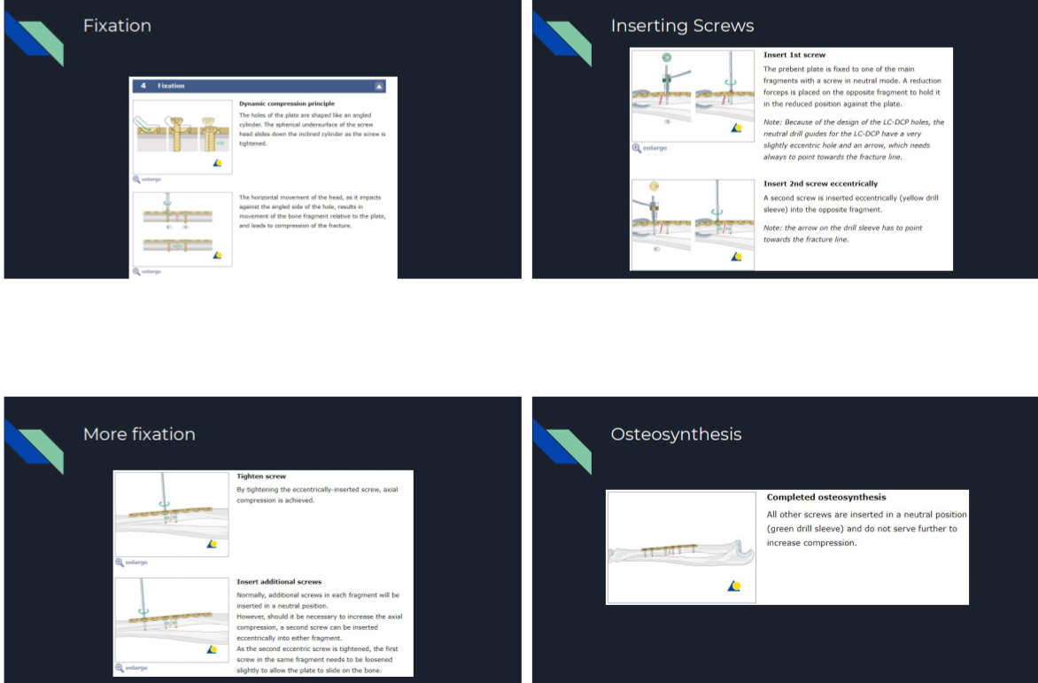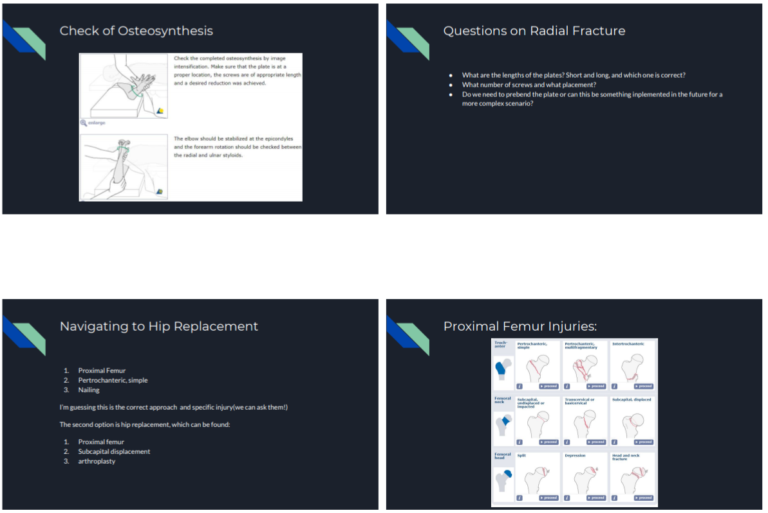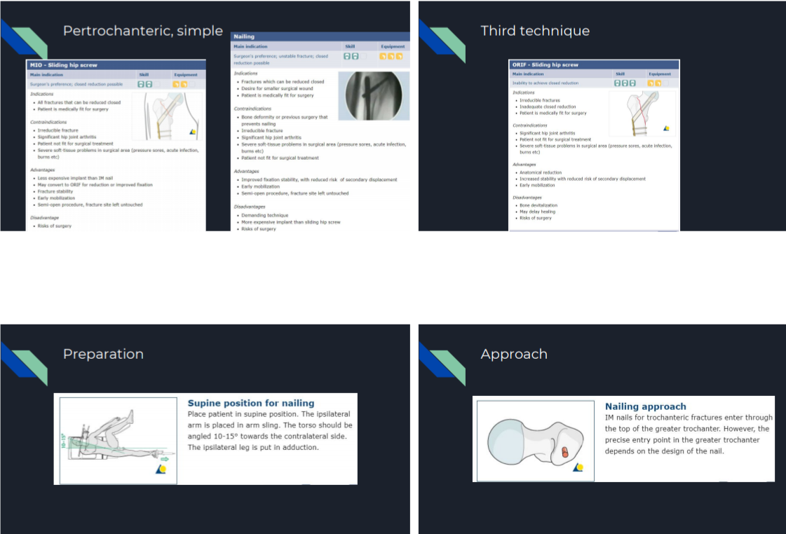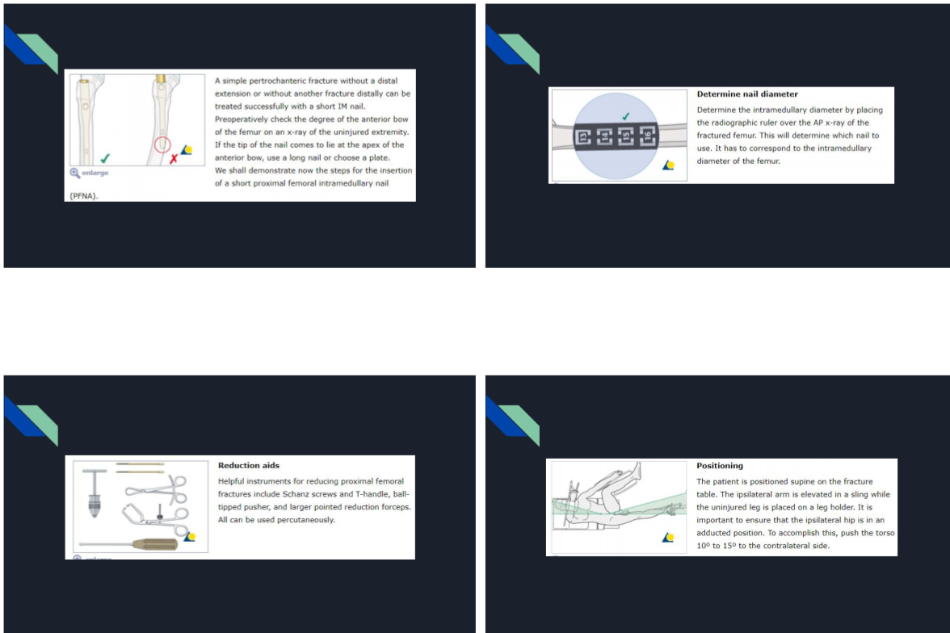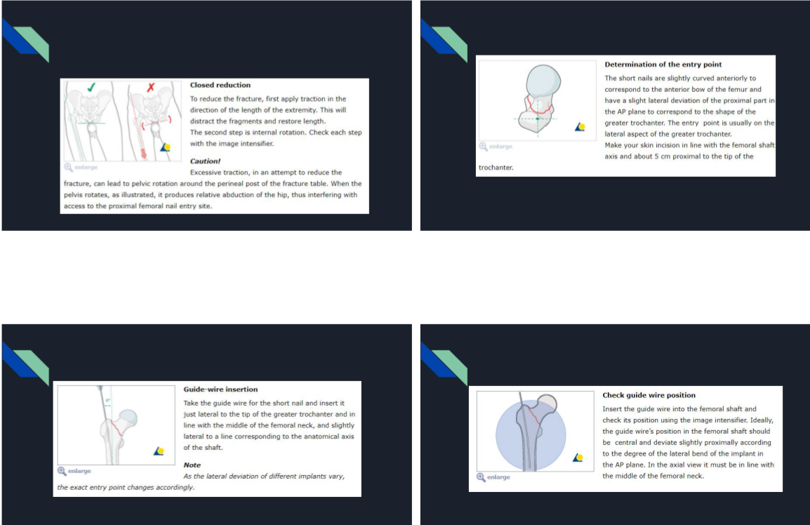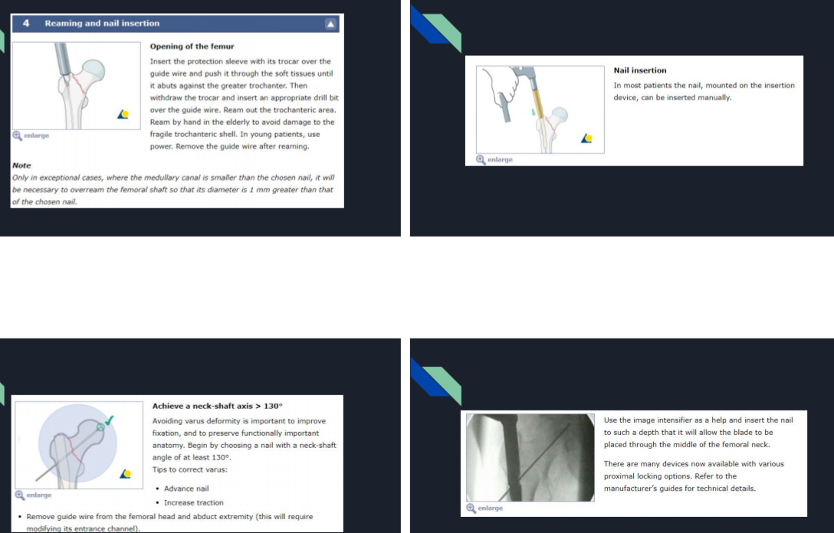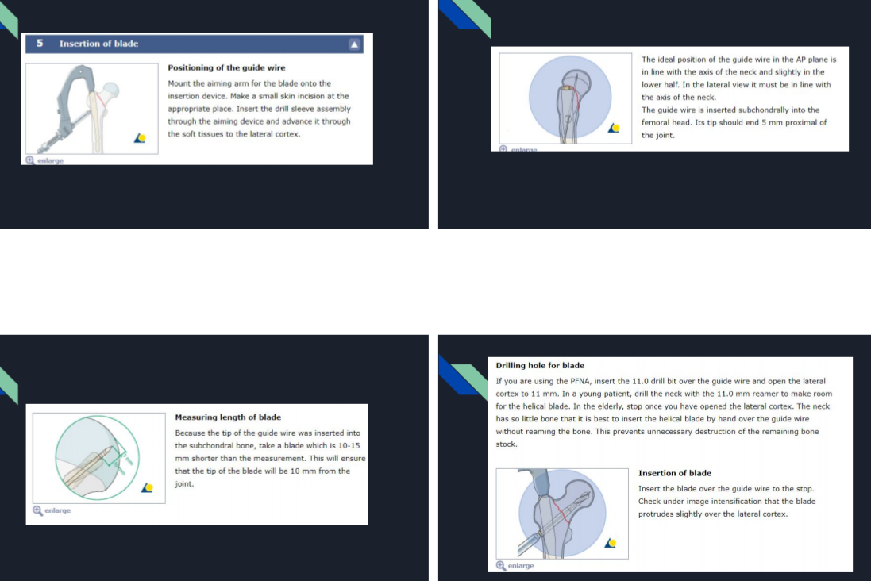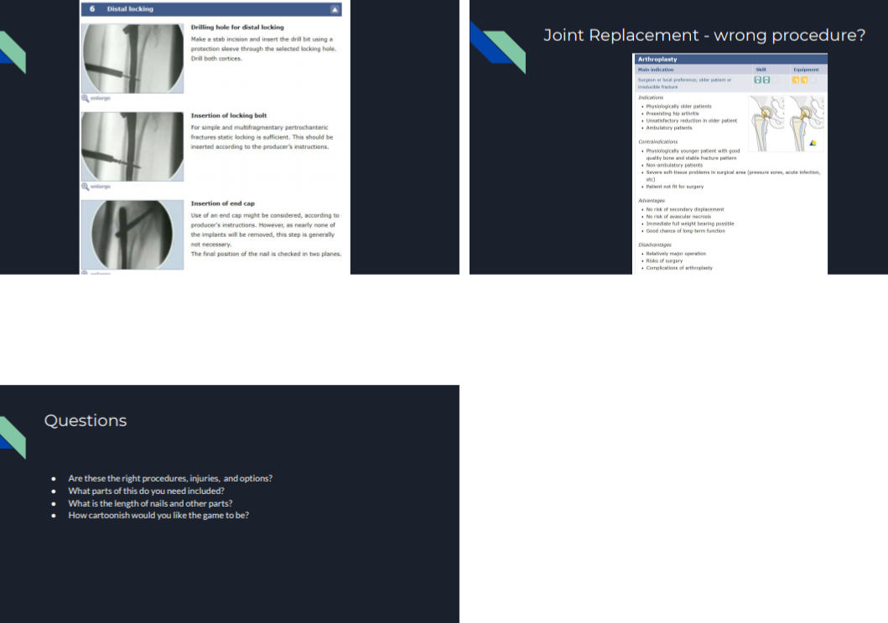

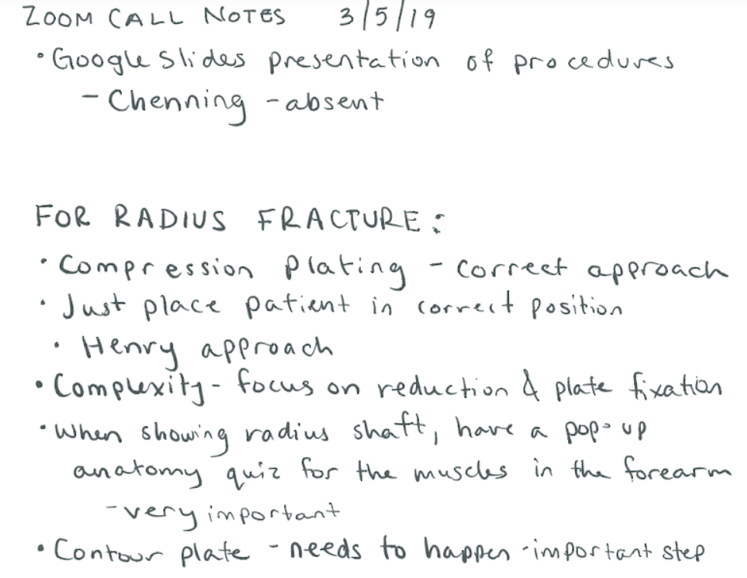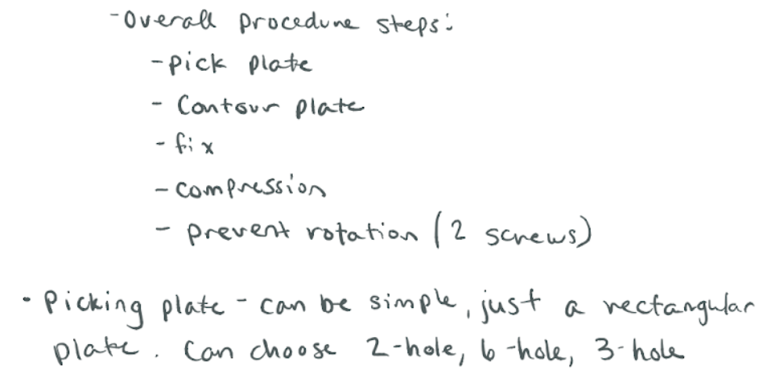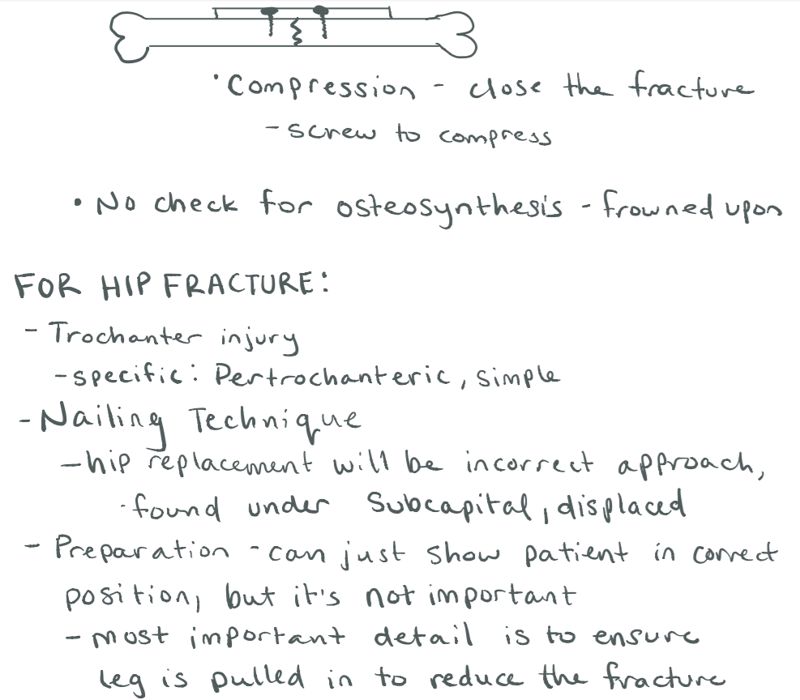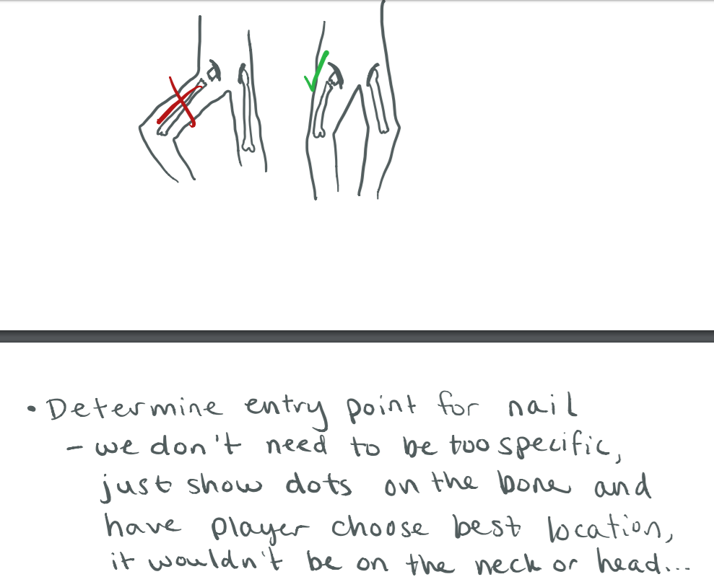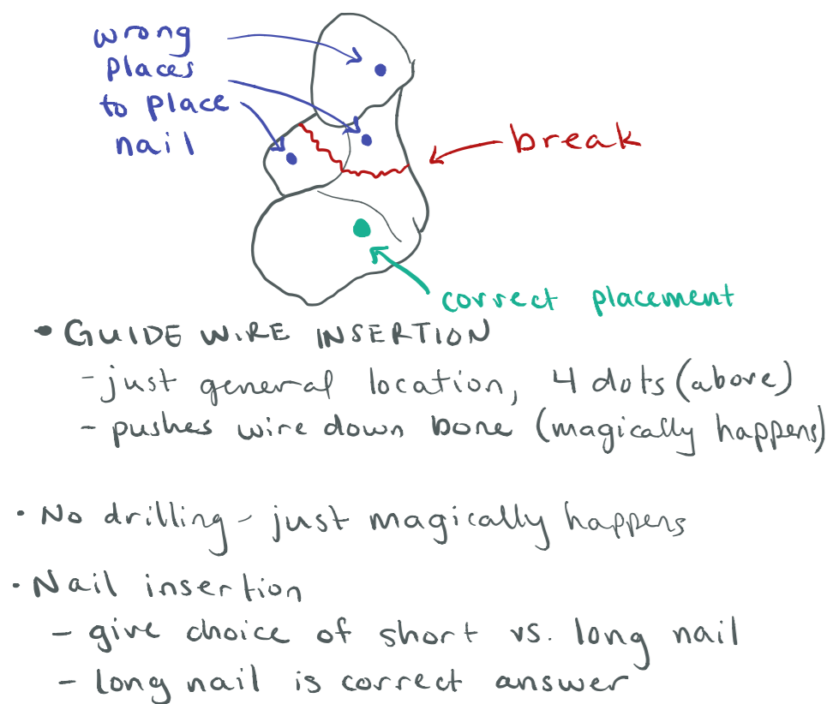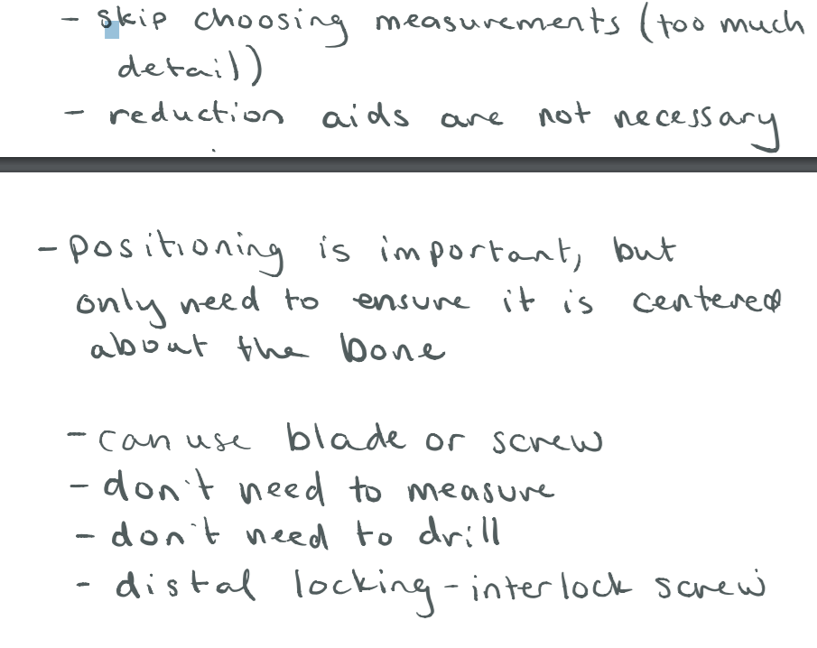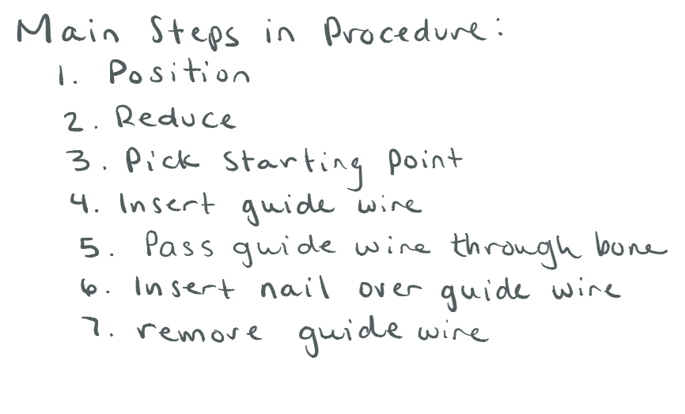

**Team Meeting Monday March 11:**

**Attendance:** Cole - present, Amber - present, Chenning - late due to traffic, let team know

**Objectives Discussed:** Code development plan, complete status report, prepare for demo, need to ask about specifics for Design Spec Report - will it be added on to proposal or separate, do we use original template?

**Update on Graphics:** We found a graphic designer, we are awaiting a response from Learning Factory

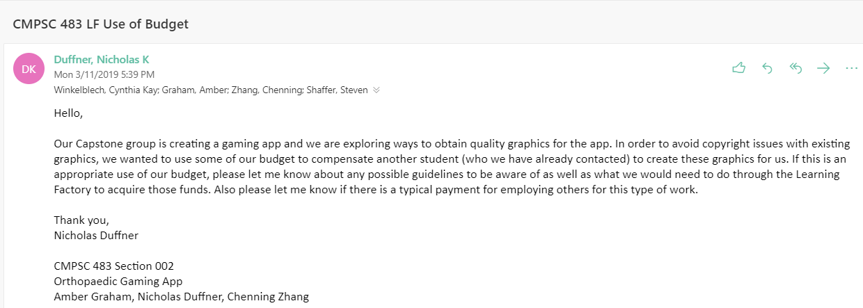

**Orthopaedic Surgery Gaming App - Week 7 Status Report**

**To:** Dr. April Armstrong,

Dr. Gary Updegrove,

Dr. Greg Lewis, PSU Hershey College of Medicine

**From:** Amber Graham, Nicholas Duffner, Chenning Zhang

**Subject:**  Progress Update for Week of March 11, 2019

**Date:** March 11, 2019

**Current Project Status:**

* Awaiting response from the Learning Factory about using our project budget to compensate another student for creating graphics.
* Currently developing our source code.

**Work Performed:**

* Researched surgical procedures to create specific stories for Trauma Scenarios.
* Presented research to sponsors via Zoom call to ensure accurate sequence of events for game and ensure appropriate level of detail.
* Found a student to create graphics for us to use in our app.
* Divided coding tasks among team.

**Team Meetings:**

* Held Zoom call with sponsors on Tuesday March 5.
* Team meeting on Monday March 11 to discuss code and weekly assignments.
* Will meet with professor for weekly meeting on Tuesday March 12.

**Goals for this Week:**

* Create home screen for game.
* Complete Design Specification Report.
* Create screens for sections of the game:
  + Nicholas: Anatomy Quiz
  + Amber: Radius Fracture Scenario
  + Chenning: Femur Fracture Scenario

**Future Work:**

* Obtain graphics for use in the app.
* Develop source code for game.
* Incorporate graphics.
* Prepare for demo to class and sponsor.

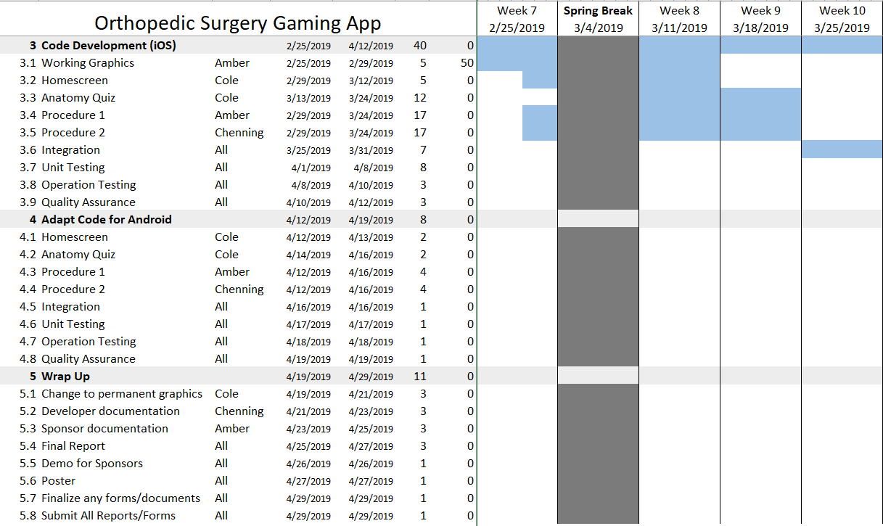

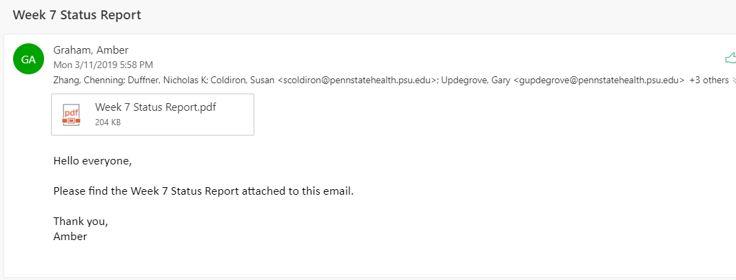

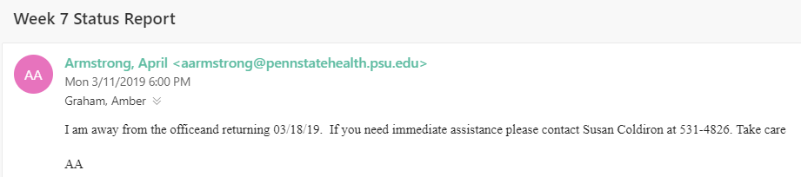

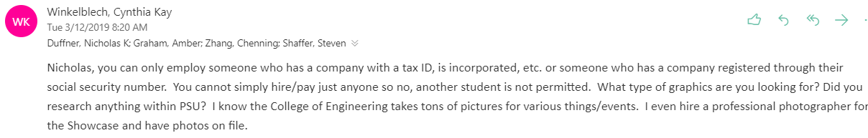

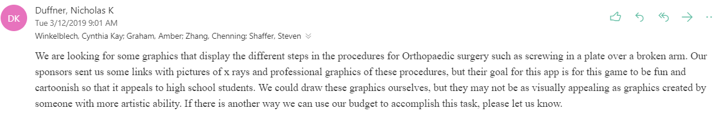

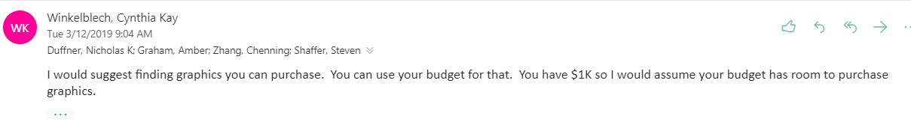

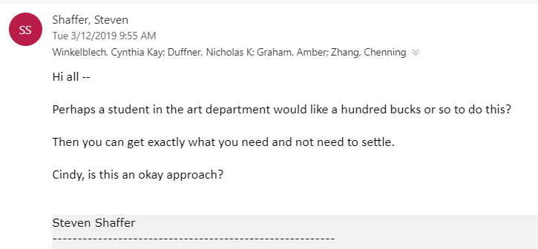

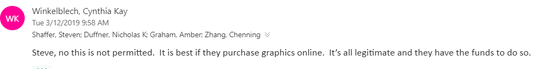

**Tuesday 3/12/2019 - Meeting with professor**

**Attendance:** All present, on time

**Discussion:**

* Have the artist sell the graphics to Shaffer, he can sell to us through his LLC.
* Or he could post the art on Etsy! (set price ahead of time)
* Fine Art America
* Amazon artisan
* Put section 8 before Team Qualification

**Saturday 3/16, Sunday 3/17**

Met to work on code and Design Specification Report

All team members present.

Developed at least one page in each section of game as well as home screen.

Integrated code to ensure proper button function and transitions.

Created executable file for demo.

**Orthopaedic Surgery Gaming App - Week 8 Status Report**

**To:** Dr. April Armstrong,

Dr. Gary Updegrove,

Dr. Greg Lewis, PSU Hershey College of Medicine

**From:** Amber Graham, Nicholas Duffner, Chenning Zhang

**Subject:**  Progress Update for Week of March 18, 2019

**Date:** March 18, 2019

**Current Project Status:**

* Developing code (iOS) for the anatomy quiz and the second trauma scenario.
* Creating graphics to use during development, and to send to graphic designer for specific graphic creation.

**Work Performed:**

* Created home screen.
* Created all screens and transitions for trauma scenario 1 (radius fracture).
* Created first question of anatomy quiz.
* Created first screen of trauma scenario 2 (femur fracture).
* Integrated all screens to ensure that transitions between them (button presses) worked properly.
* Created demo of game in its current state in development for in-class demonstration.
* Added Detailed Design and improved Patent Search sections to the SOW Report.

**Team Meetings:**

* Team met on Saturday 3/16 to develop code for game.
* Team met on Sunday 3/17 to develop code for game and write Design Specification Report.
* Will meet with professor on Tuesday 3/19 for weekly status meeting.

**Goals for this Week:**

* Complete Design Specification Report after meeting with the professor.
* Ensure that transitions between screens are accurate.
* Amber: Create remaining graphics for use during development.

**Future Work:**

* Obtain permanent graphics for use in the app.
* Complete development of source code for game.
* Incorporate graphics.
* Prepare for demo to sponsor.

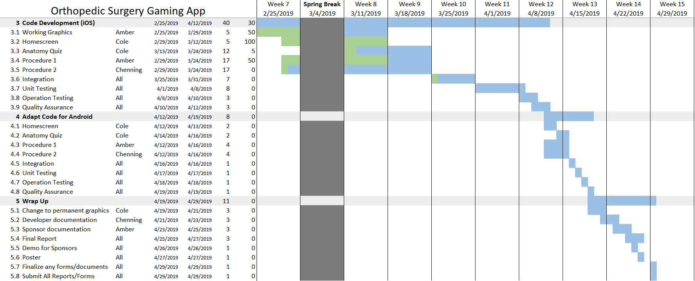

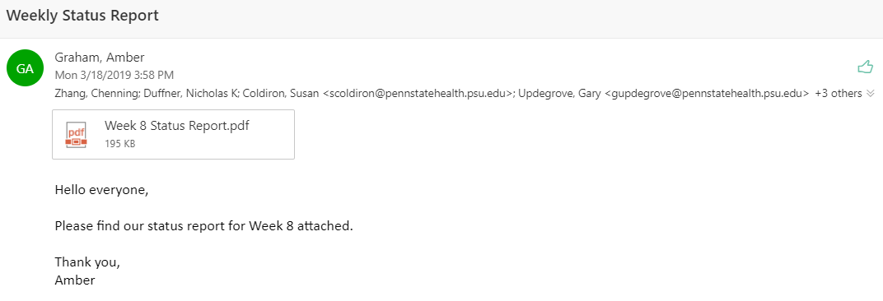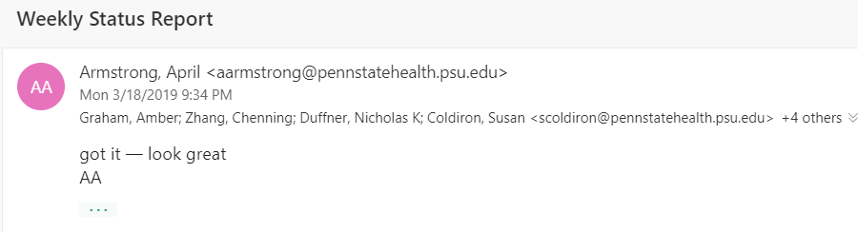

**Orthopaedic Surgery Gaming App - Week 8 Status Report**

**To:** Dr. April Armstrong,

Dr. Gary Updegrove,

Dr. Greg Lewis, PSU Hershey College of Medicine

**From:** Amber Graham, Nicholas Duffner, Chenning Zhang

**Subject:**  Progress Update for Week of March 25, 2019

**Date:** March 25, 2019

**Current Project Status:**

* Adding code (iOS) for the anatomy quiz and each trauma scenario.
* Creating graphics to use during development, and to send to graphic designer for specific graphic creation.

**Work Performed:**

* Presented working project prototype to the class.
* Prepared prototype and fixed small issues with scenario #2 before presenting demo to our sponsors this week.

**Team Meetings:**

* Team met on Tuesday 3/19 to present demo and make improvements to prototype.
* Will meet with professor on Tuesday 3/26 for weekly status meeting.

**Goals for this Week:**

* Record video of prototype demonstration to send to sponsors for review.
* Make necessary additions to working prototype to make a more full game.
* Collect existing graphics needed to send to artist.

**Future Work:**

* Obtain permanent graphics for use in the app.
* Complete development of source code for game.
* Incorporate graphics.

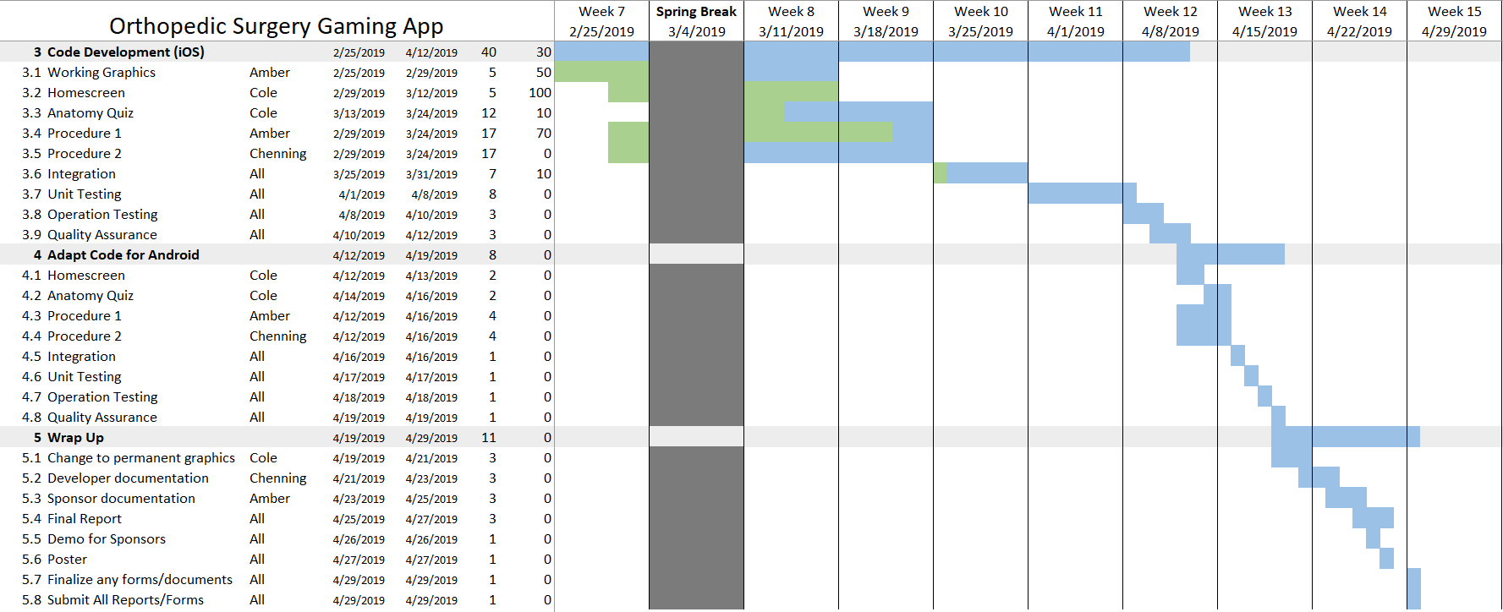

**Monday 3/25**

Usually we have a team meeting on Monday, but as our current work requires each team member to work on their portion of the code, we have elected to work independently today.

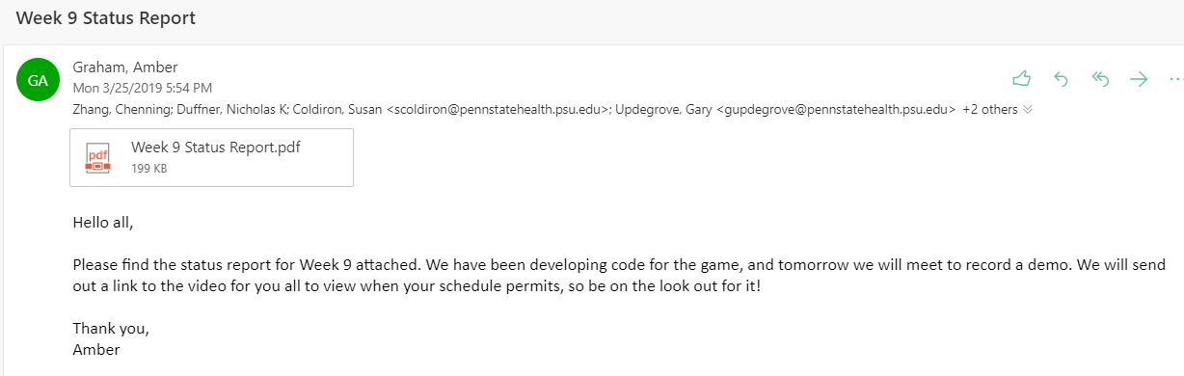

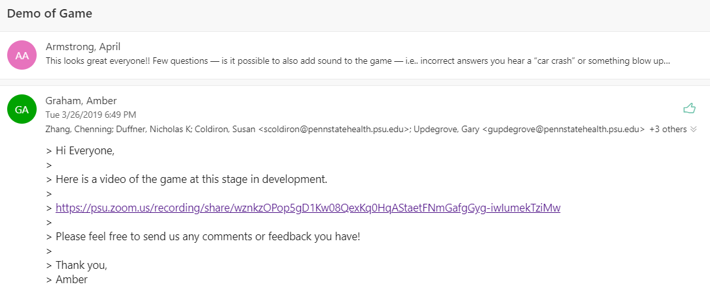

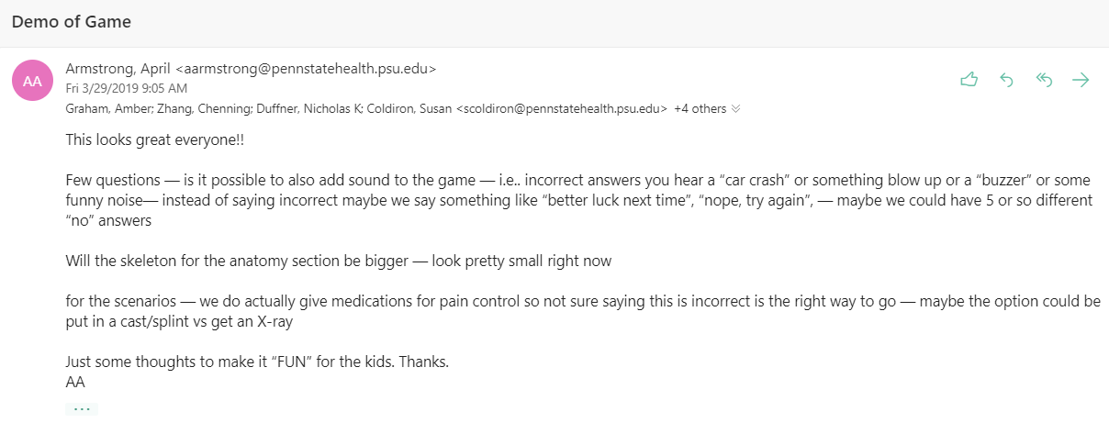

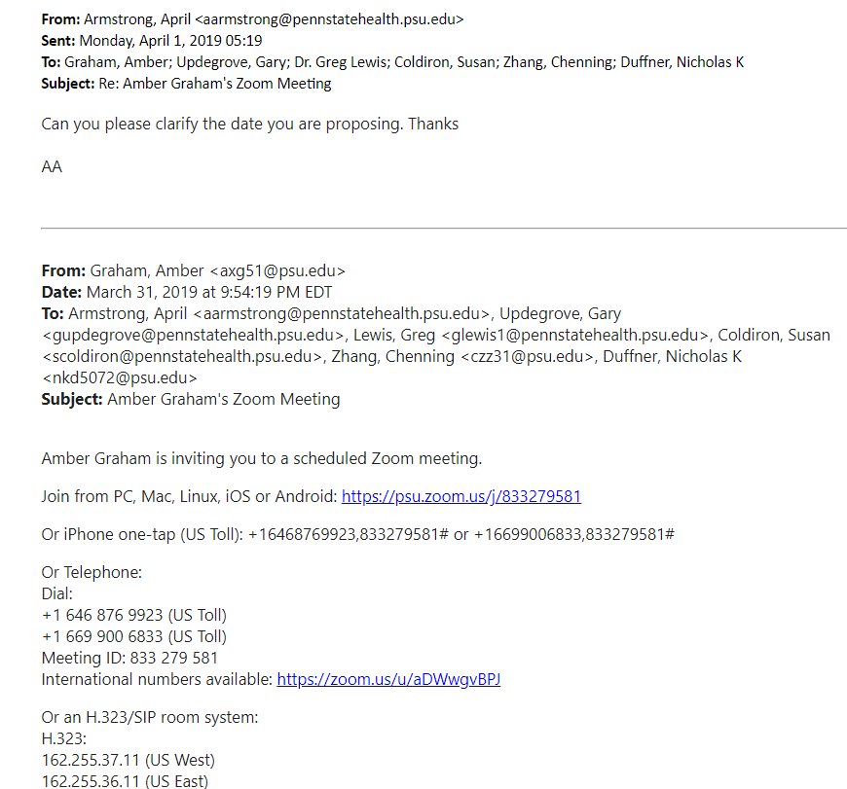

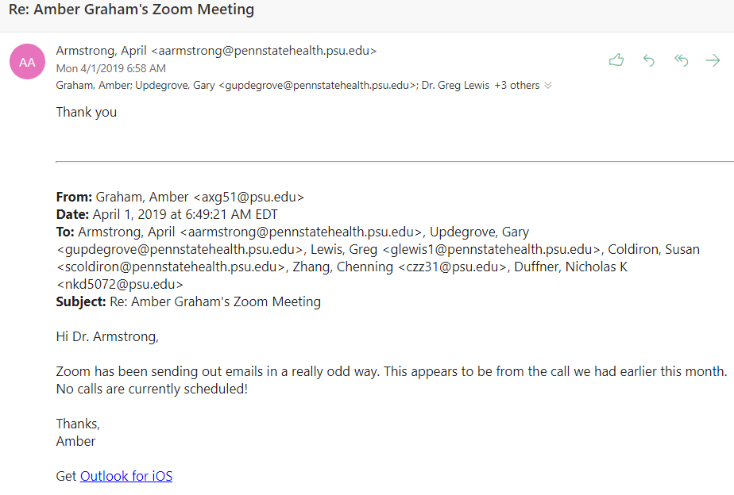

**Monday 4/1/2019**

Amber and Chenning met to correct femur fracture screens.

Cole sick, working from home on Anatomy Quiz.

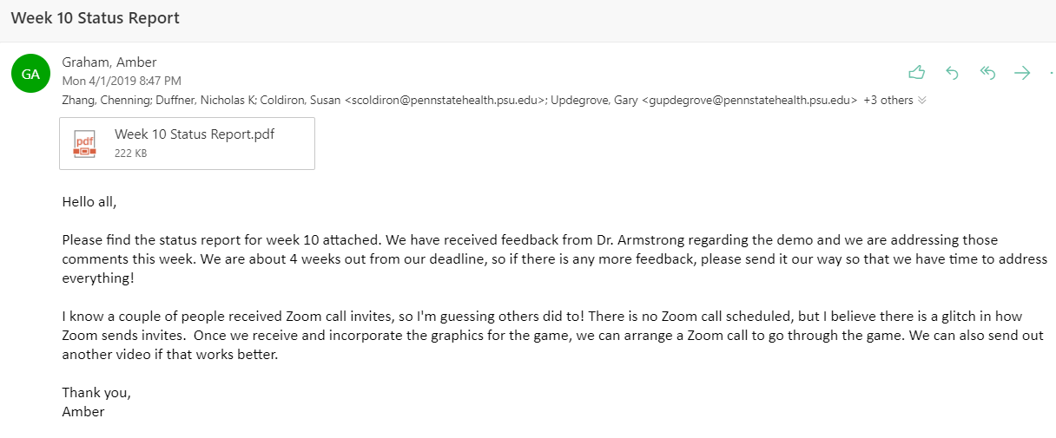

**Orthopaedic Surgery Gaming App - Week 10 Status Report**

**To:** Dr. April Armstrong,

Dr. Gary Updegrove,

Dr. Greg Lewis, PSU Hershey College of Medicine

**From:** Amber Graham, Nicholas Duffner, Chenning Zhang

**Subject:**  Progress Update for Week of April 1, 2019

**Date:** April 1, 2019

**Current Project Status:**

* Adding code (iOS) for the anatomy quiz and each trauma scenario.
* Graphic Designer working on all game graphics.

**Work Performed:**

* Presented working project prototype to sponsors and received feedback.
* Created development graphics for home screen, anatomy quiz, radius fracture, and femur fracture.
* Handed graphics over to artist.
* Made corrections to femur surgery to match procedure details specified by sponsors.

**Team Meetings:**

* Team met on Tuesday 3/26 to record demo and send to sponsors.
* Team met on Monday 4/1 to make corrections to femur surgery.
* Will meet with professor on Tuesday 4/2 for weekly status meeting.

**Goals for this Week:**

* Complete development of Anatomy Quiz and Femur Surgery.
* Address feedback from sponsor regarding demo.

**Future Work:**

* Obtain permanent graphics for use in the app.
* Incorporate permanent graphics.
* Gather publishing and copyright information for sponsors (deliverable item).
* Write technical documentation for future development (deliverable item).

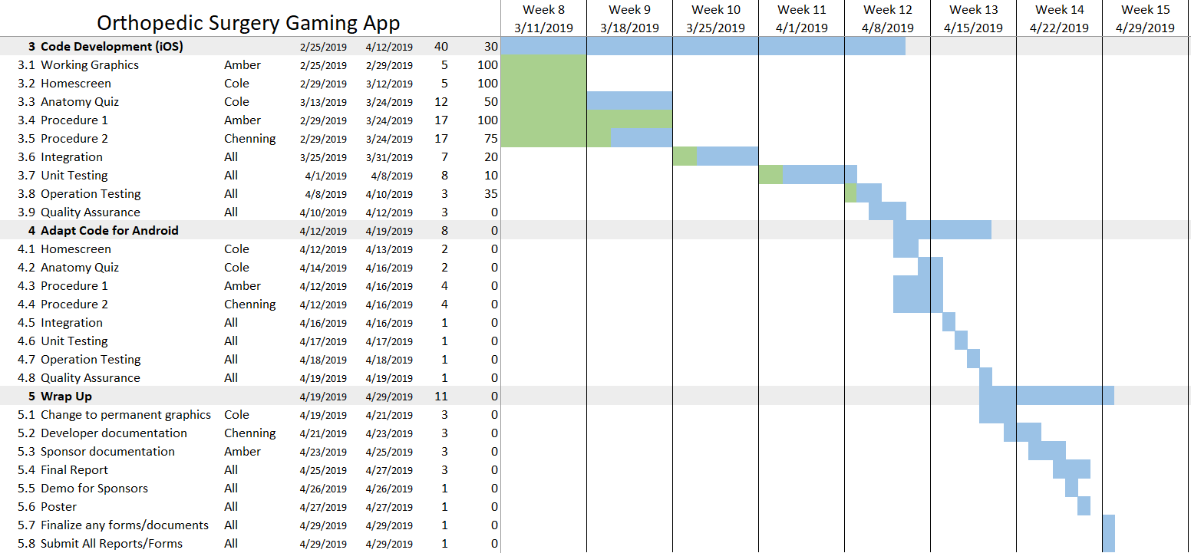

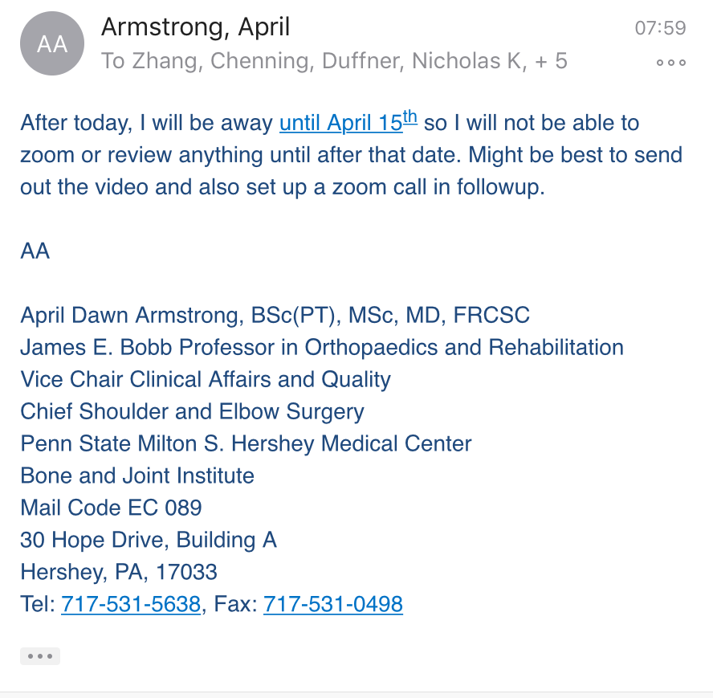

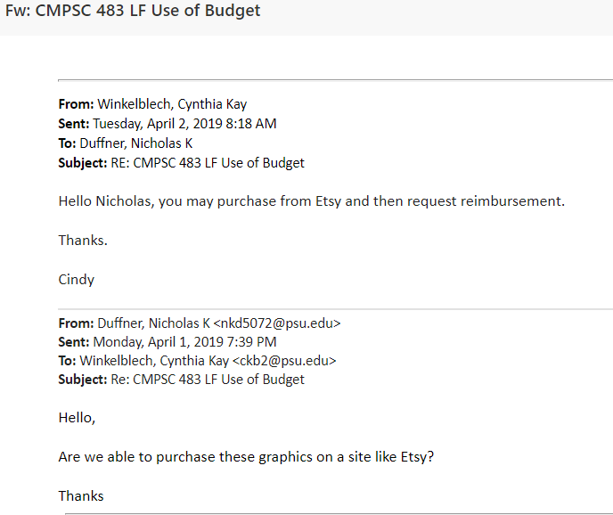

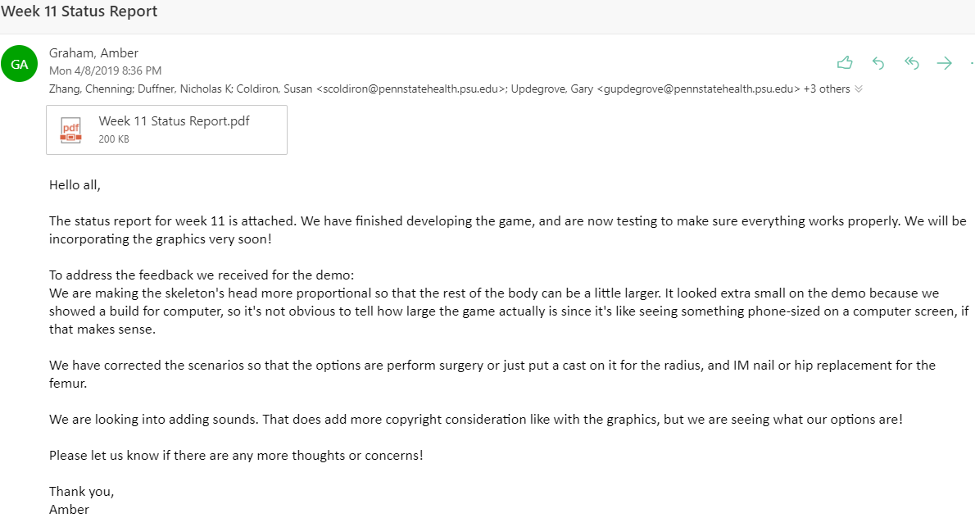

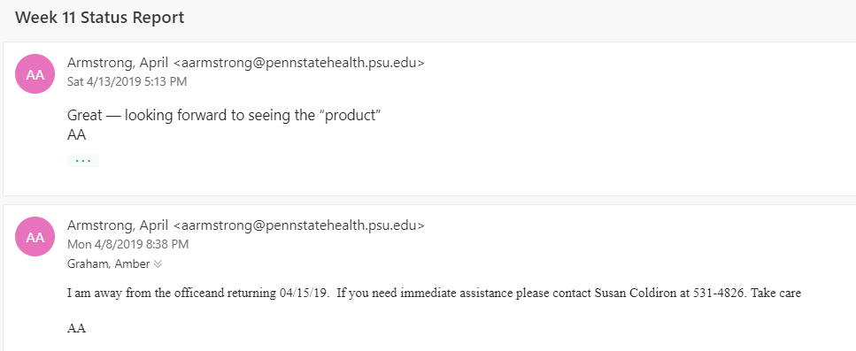

**Monday 4/15**

Team meeting to make poster for showcase. All team members present and on time.

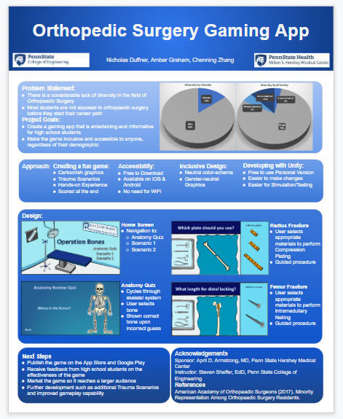

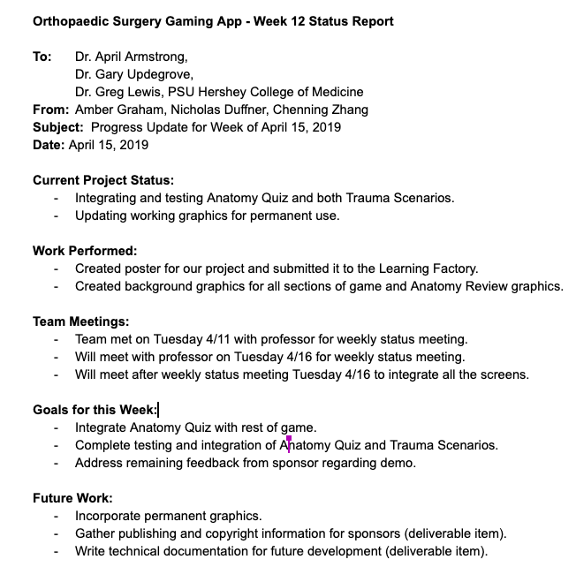

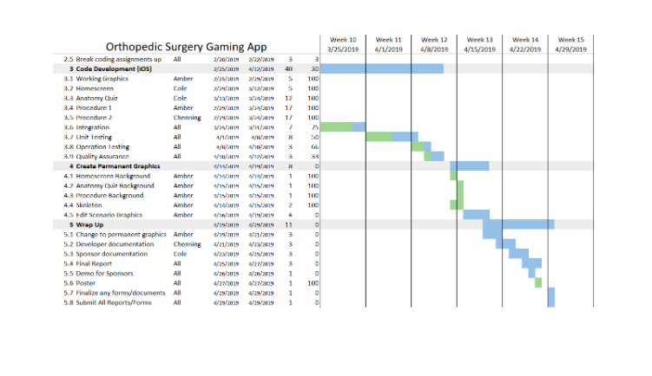

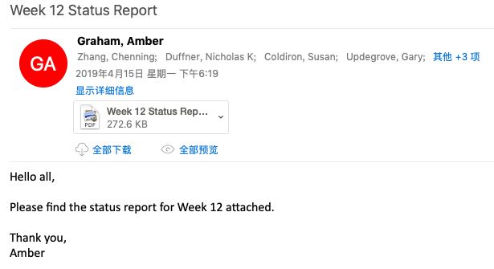

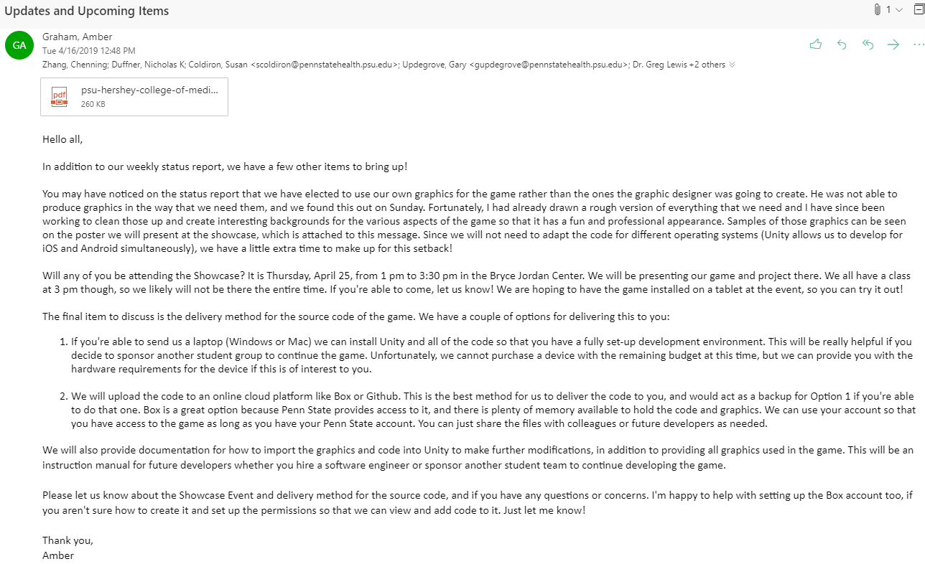

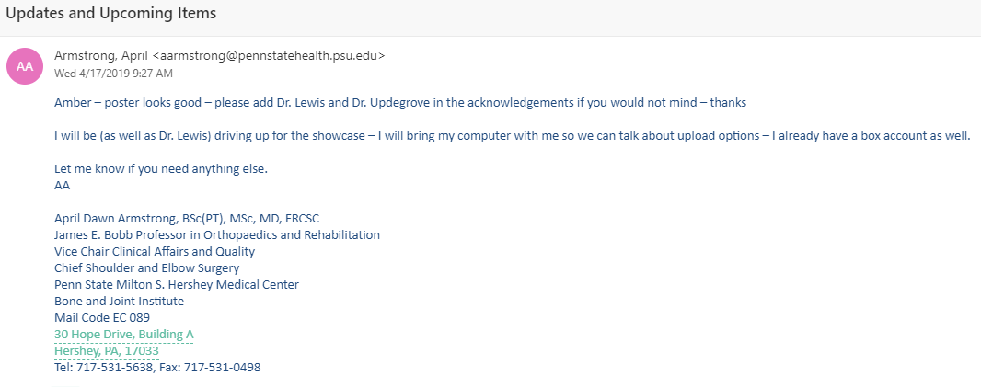

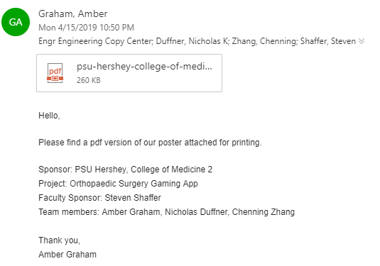

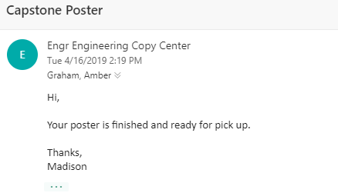

**Tuesday 4/16**

Meeting with professor, discussed graphic design problem and solution and current status on project. All team members present and on time. Will meet to integrate code on Friday.

**Sunday 4/14 - Tuesday 4/16**

Amber created graphics for Home Screen, Anatomy Quiz, and Radius Fracture, uploaded them to Google Drive folder. Will create femur fracture graphics by Friday afternoon.

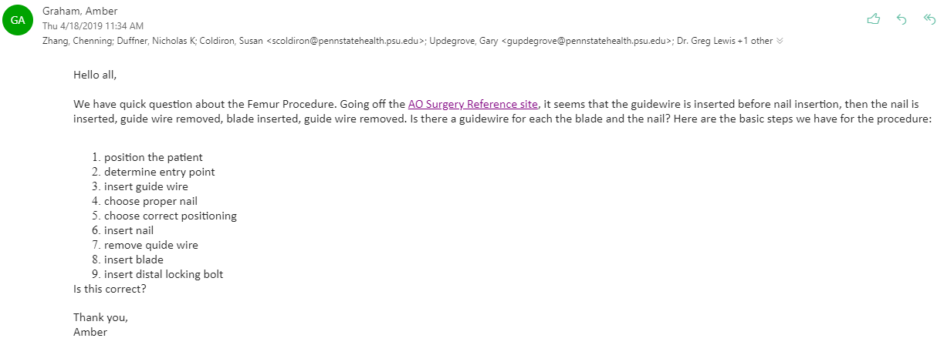

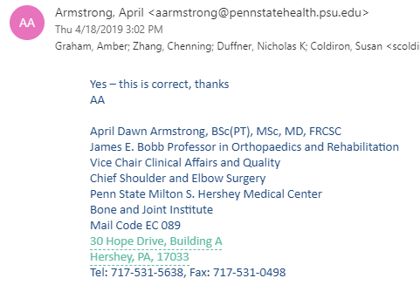

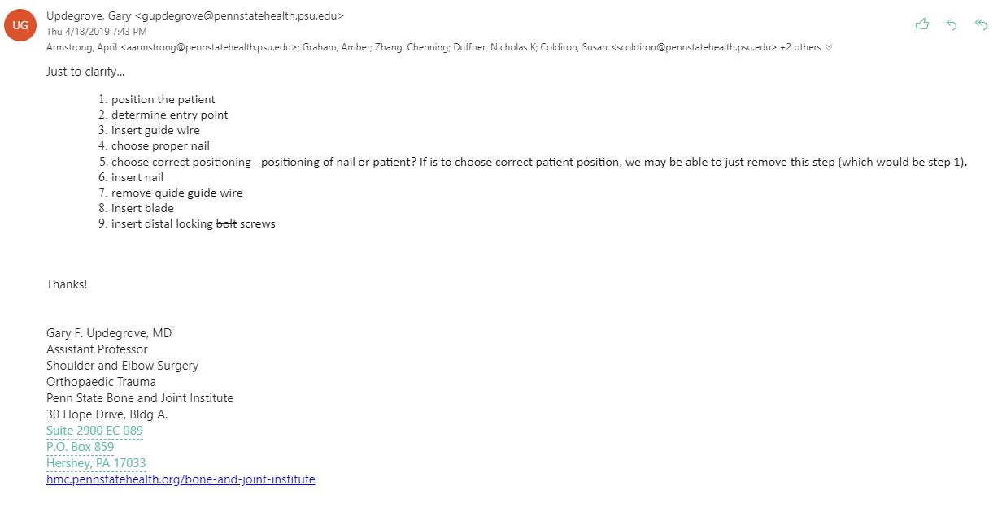

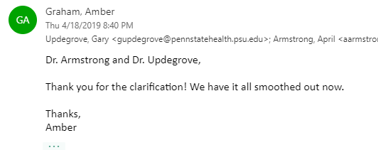

**Friday 4/19**

Team met in library from 2:30 - 5:30 to work on integration and changing to permanent graphics. We were able to use Unity Collaboration built-in function to integrate our code more seamlessly, so that we are all able to access and build the full game. This will save us a lot of time as we will not need to integrate and add graphics on each of our devices separately. This way, we can each be sure we are testing the same version of the code, and corrections we make immediately go out to the other members.

All team members were present for this meeting.

**Sunday 4/21**

Team met to integrate and test code, and record demo video. Unfortunately, we ran into errors with the way graphics displayed while playing the full game and had to investigate that. Still working to make needed adjustments to layouts of screens. All team members were present and on time.

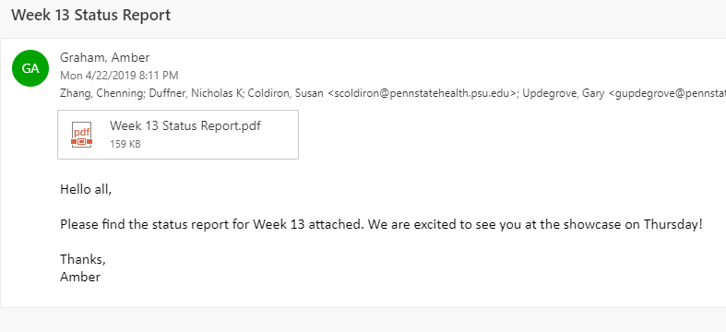

**Orthopaedic Surgery Gaming App - Week 13 Status Report**

**To:** Dr. April Armstrong,

Dr. Gary Updegrove,

Dr. Greg Lewis, PSU Hershey College of Medicine

**From:** Amber Graham, Nicholas Duffner, Chenning Zhang

**Subject:**  Progress Update for Week of April 22, 2019

**Date:** April 22, 2019

**Current Project Status:**

* Permanent graphics are in place.
* Testing for proper operation is complete.
* Currently adjusting screen layouts so that text, buttons, and graphics are properly oriented for different screen sizes.

**Work Performed:**

* Created all graphics for the game and incorporated them into the game.
* Integrated all parts of the game.
* Tested for accurate button operation and spelling/informational accuracy.

**Team Meetings:**

* Met with professor on Tuesday 4/16 for weekly status meeting.
* Met on Sunday 4/21 for code integration and testing.
* Will meet Tuesday 4/22 to record demo.

**Goals for this Week:**

* Record final demo.
* Complete builds for iOS and Android.
* Complete all reports and documentation.
* Attend project showcase.

**Future Work:**

* Gather publishing and copyright information for sponsors (deliverable item).
* Write technical documentation for future development (deliverable item).
* Deliver source code and documentation to Sponsor.

